


Final report

An Investigation on Biogas Plant

Development in China

Institute for Techno-Economic Energy System Analysis
(ITEESA)
Tsinghua University, Beijing, China
March, 2001

An investigation on biogas plant

Development in China

Team leader Gu Shuhua

Team members Zhang Xiliang Wang Gehua Zhou Mengjin

Jin Yao Zeng Banglong Yao Xiangjun
Sun Zhenqing Duan Maosheng Liu Zhihua

Institute for Techno-Economic Energy System Analysis (ITEESA)
Tsinghua University, Beijing, China
March, 2001

Terms of Reference (CN0101.01)

An Investigation on Biogas Plant Development in China

- Background

In the past two decades, due to the successful implementation of the economic reforms and open policies by Chinese government, the GDP of China increased at the rate of 9.6% annually and the per capita annual disposable income of urban households increased at the rate of 6.2%. In order to meet the rapid growing demands, Chinese government began to formulate and implement the “Vegetable Basket” program in 1988, requiring that all provinces and municipals actively develop agriculture farms and breeding farms to supply more meat, eggs and poultry, as well encourage peasants to produce and supply more food. Up till now, there are about 14.8 thousand breeding farms with more than 1,000 pigs or 100 cows or 100,000 chickens being raised. Most of these farms locate in the suburban areas of large or medium cities. By 1998, the pork production has reached 38.84 million tons, which is more than 1.35 times that of 1995 (16.55 million tons). The production of meat, eggs and poultry from large-scale breeding farms has accounted for a considerable percentage of the total amount, and this situation is more obvious in large cities. For example, the number of pigs and fowls raised in large-scale breeding farms was 85% and 96% of their total amount in Beijing, 80% and 95% in Shanghai, and 30% and 75% in Hangzhou. It is predicted that the large-scale farms will keep their development trends.
The rapid growth of large-scale breeding farms, however, also brought heavy pollution while they provide more meats and eggs to households in city and countryside. According to estimation, the breeding farms in China discharge 250,000 tons excrement and urine effluents each day and this figure will reach 2 million tons if the washing water was included. That is, the annual discharge volume will be 720 million tons. These wastes could be used as fertilizers. Only a part of the waste could use as fertilizers due to the seasonal characteristics of plantation. As a result, these effluents have to be discharged directly to surrounding areas for 8-9 months each year. They contain large amount of pollutants. For example, the CODs in the mixture of excrement and urine of pigs and cows are 81,000mg/l and 36,000mg/l respectively, which is 50-70 times that of standard discharge. When these biochemical effluents flow into farmlands, they lead to over-nutrient and the crops grow crazily while the yields decline; when flowing into pond, they can cause fish death because of the fish’s sensitivity to organic pollution; When flowing into rivers, they contaminate the water. There are extremely foul smells in sunny days and wastewater everywhere in rainy days. And the effluents not only accelerate the breading of flies and mosquitoes but also enhance the spreading of epidemic diseases. The sanitation situations in residential areas are deteriorated. Therefore the wastes discharged from breeding farms not only pollute the surrounding environment, but also prevent the future development of the farms themselves.
In China, large and medium biogas plant refers to the whole set of devises which take the function of anaerobic digestion of organic wastes, biogas producing, and pollution treatment.
The anaerobic digestion is a biochemical process in which the organic matters are decomposed and digested by several kinds of microorganism without the participation of oxygen and finally biogas is produced. A biogas plant includes 3 systems: pre-processing, anaerobic digestion and post-processing. After pre-processing, organic wastes enter the anaerobic digestion device to step into the state of ferment and yield biogas. The main component of the biogas is methane, which occupies 50~70% of the total volume and whose heat value is 23.4MJ/m³. After desulfuration and dehydration, biogas enters gas-storage as a nicer fuel for civilian use, or as the fuel to produce electricity. Furthermore, the solid residues of anaerobic digestion can be made into organic fodders or fertilizer after post-processing, and the liquid residues can be used as fertilizer or discharged directly after aerobic processing.
In China, the technologies utilizing the excrement and urine of fowl and livestock have become mature, although the starting of them are later and the basis are poorer compared with those of developed countries. Now according to the different raw materials, Chinese engineers can deal with the overall design, implementation and operation of biogas plants, including pre-processing, anaerobic digestion, gas distribution, and fertilizer making, and post-processing. Some technologies and index, such as biological anaerobic digestion mechanism research, fermentation technologies dealing with different kinds of excrement and urine, biogas production rate, COD removing rate etc., have been advanced in the world. The anaerobic digestion devices installed in a biogas plant include combined anaerobic digestion tank, anaerobic sludge-bed reactor, two-phase anaerobic digester, and so on. There are about 840 biogas plants all over the country, 530 of which are for treating agricultural residues and wasters. These plants have a total capacity of 143,000 m³; they can process 4.2 million tons wastes and produce 23.8 millions m³ biogas annually, which can be used as household fuel to serve 51,000 households. Besides, they also provide 20,000 tons of fertilizers or fodder.
Anaerobic digestion biogas plants should become one of the important and indispensable accessories of breeding farms. The State Environment Administration, Ministry of Agriculture and State Technology Supervision Agency have jointly drafted two regulations: Discharge Standard of Effluents from Livestock Breeding and Prevention, Cure and Management measures on Effluents from Livestock Breeding. The two regulations will be promulgated and put into effects soon. Some regions have also issued some regulations and ordinances on the prevention and cure of effluents from livestock breeding. For example, Shanghai has issued Temporary Regulations on Effluents from Livestock Breeding. In Control Ordinance on Agriculture Eco-Environment issued by ten provinces and municipalities there are also some clauses about the prevention and cure of effluents from livestock breeding.
We can say that the Chinese biogas technologies have become mature and been in the early stage of scale development. Management and service infrastructure related has also been established. The government has issued related policies and regulations as well. As a result, the biogas plants should boom up. However, up till now there’re few breeding farms that have biogas plants. According to an incomplete estimation, this rate is below 5%. Even in Shanghai, who is the biggest city and most flourish region of China, this rate is below 10% although there are about 1,000 breeding farms in the suburb of this city. The reasons for slow development of biogas plants are various, needing fieldwork in depth and careful analysis. The current situtation indicates that there’re some barriers: first, biogas plants often need a large amount of initial investment. The farm owner is reluctant to invest in the biogas project, which brings risk before the breeding farm itself makes a significant progress. Second, the farm owners and the public lack the consciousness of environment protection. Some breeding farms built biogas projects only when government provided part subsidies and their motivation is to avoid penalty and to disburden the stress. In addition, that environment protection department did not implement the regulations strictly also had a negative impact on the development of biogas plants. Other farm owners take building the biogas projects just as welfare their workers in the farm. They didn’t care the gains from the gas and residues produced in biogas plants when, and they cannot promote the development of biogas plants through commercialization. In addition to strengthening the implementation of existing regulation, what measures the government should take to facilitate the development of biogas plants is till a important questions to be investigated.

- Objectives

Based on reviewing the existing information and conducting several case studies of cities and breeding farms, this project is to understand the current situations of and problems in biogas plant development, and to analyze prospects,barriers, and solutions involved in the commercialize of biogas plants. The specific objectives of the project are to:

1) Conduct analysis of the current situation of biogas plant development, covering the development of breeding farms in China and the technological, economic, and environment context of biogas plant development;
2) Investigate the scale, management, technical service system, policies, and the institutional infrastructure of China's biogas industry.

- Activities

1. Review the biogas plant development in China;

- Field investigation and case studies

2.1. Investigating the development of biogas plants in two cities;
2.2. Conducting four cases studies of biogas plants in breeding farms

- Duration

This project will start in October, and be finished within 3 months.

- Output

The major output of the project is the final report with field investigation and case studies

Content

Terms of Reference (CN0101.01)

Report 1. Investigation on Biogas Engineering of Breeding farms in China 1

Report 2. Investigation on Biogas Plant Development in Urban Breeding farms 16

Case 2.1: Investigation on the Development of Biogas Plants in Breeding Farms in Shanghai 17
Case2.2: Investigation on the Development of Biogas Plants in Breeding Farms in Beijing 26
Case2.3: Investigation on Biogas Plant Development in Breeding Farms in Hangzhou 33
Annex: Investigation Outline forBiogas Plant Development in Urban Breeding farms 37

Report 3. Investigations on Biogas Plant in China 38

Case 3.1 Investigation on Biogas Power Generation of Quantou Farm, Fuzhou 39
Case 3.2 Investigation on Biogas Plant of Nanhangji Pig Farm, Fangshan District, Beijing 43
Case 3.3 Investigation on Biogas Plant of Dulehe Orchard and Pig Farm, Pinggu County, Beijing 46
Case 3.4 Investigation on Biogas Plant of Gaoqiao Breeding Farm, Chedun Town, Songjiang District, Shanghai 49
Case 3.5: Investigation on Biogas Plant and Water Treatment of Dengta Breeding Farms, Hangzhou 52
Case 3.6 Investigation on Biogas Plant of Hongming Breeding Farm, Shanxi 58
Case 3.7 Investigation on Biogas Plant of Jingshan Pig Farm, Hubei Province 61
Annex Investigation Outline on Biogas Plant Cases of Breeding Farms 64

Report 1. Investigation on Biogas Engineering of Breeding farms in China

1. Large & medium-scale breeding farms and related pollution status in
China
  - Number and scale of large & medium-scale breeding farm
There are about 14,000 large & medium-sized breeding farms in China by the end of 1997 according to incomplete statistics based on investigation on 33 provinces, autonomous regions and municipalities (including cities specifically designated in the state plan).

Table 1.1 Number of large & medium-sized breeding farms by scale
 | pig farm with 1000-  5000 | Cattle farm with 100-400 | Poultry farm with 100,000-  300,000 | pig farm  above 5000 | Cattle farm above 400 | Poultry farm above 300,000 | Total
Beijing | 746 | 40 | 218 | 125 | 12 | 47 | 1188
Tianjin | 360 | 3 | 41 | 50 | 20 |  | 474
Shanghai | 344 | 145 | 425 | 78 | 22 | 51 | 1065
Chongqing | 106 | 121 | 11 | 17 | 23 |  | 278
Hebei | 60 | 32 | 10 | 18 | 27 | 2 | 149
Shanxi | 110 | 181 | 44 | 15 | 22 | 8 | 380
Inner Mongolia | 2 | 1 | 26 |  | 2 |  | 31
Liaoning | 254 | 427 | 154 | 76 | 25 | 6 | 942
Jilin | 34 | 96 | 11 | 7 | 25 | 2 | 175
Heilongjiang | 65 | 28 | 478 | 14 | 13 | 10 | 608
Jiangsu | 347 | 21 | 67 | 41 | 10 | 6 | 492
Zhejiang | 505 | 20 | 64 | 76 | 4 |  | 669
Anhun | 310 | 21 | 46 | 120 | 18 | 15 | 530
Fujian | 650 | 25 | 18 | 226 | 19 | 11 | 949
Jiangxi | 1586 | 380 | 37 | 77 | 9 |  | 2089
Shandong | 235 | 144 | 275 | 112 | 32 | 97 | 895
Henan | 250 | 90 | 176 | 150 | 25 | 10 | 701
Hubei | 322 | 19 | 175 | 53 | 6 | 14 | 589
Hunan | 778 | 18 | 17 | 112 | 4 | 6 | 935
Guangdong | 256 | 36 | 285 | 98 | 15 | 105 | 795
Guangxi | 78 | 7 | 21 | 4 | 3 | 2 | 115
Hainan |  | 2 | 2 | 18 |  |  | 22
Sichuan | 41 | 87 | 38 | 10 | 30 | 22 | 228
Guizhou | 10 | 6 | 1 |  | 5 |  | 22
Yunnan | 27 | 6 | 16 | 4 | 5 | 3 | 61
Shaanxi | 40 | 66 | 10 | 20 | 10 | 2 | 148
Gansu | 75 | 65 | 10 | 37 | 19 | 5 | 211
Ningxia | 1 | 1 | 1 | 11 |  |  | 14
Total | 7592 | 2088 | 2677 | 1569 | 405 | 424 | 14755
  - Distribution characters of large & medium-scale breeding farms
Breeding farms are mainly concentrated in East China & coastal area. Considering number, scale and regional density, the top 10 provinces and municipalities are Fujian, Guangdong, Shanghai, Beijing, Shandong, Jiangxi, Jiangsu, Zhejiang, Liaoning and Hunan. Due to the high density of population and rapid development in economy, the demand on livestock products is very great.
Breeding farms are mainly spread densely around large cities such as Beijing, Shanghai & Guangzhou. With population & population density increase the number & density of breeding farms increase too. Livestock products meet the demand of local residents and thus the transportation cost was reduced.
Nearly 80% of breeding farms are concentrated in east coastal China and cities while that in central China and west China only take 20% and 1% respectively.
  - Pollution status of large & medium-sized breeding farms
The development of livestock breeding has met living demand for people, contributing a lot for improvement of resident’s life both in rural and urban areas. However simultaneously large quantity of excrement has brought a series of environmental problems. Investigation has been carried out on effluent discharge in Beijing, Shanghai & Hangzhouas show in table 1.2, among which the volume of treated effluent is less than 5%. Most of excrement from breeding farms isn’t treated and utilized, therefore the excrement loading capacity per unit area is very high in city-surrounding area and suburb which had brought about severe environmental pollution.

Table 1.2 Discharge of excrement and urine from livestock breeding in 1997

City | Variety | Number of slaughtered  (10,000) | Percentage of scaled breeding | Number of scaled breeding farm | Volume of effluent in scaled breeding farms (10,000 ton) | Total volume of effluent (10,000 ton)
Beijing | Pig | 353.5 | 85 | 871 | 603.2 | 661.2
Beijing | Poultry | 3376.2 | 96 | 265 | 354.9 | 369.7
Beijing | Cattle | 15.0 | 99 | 52 | 162 | 162.2
Beijing | Total |  |  | 1188 | 1120.1 | 1193.1
Shanghai | Pig | 450 | 80 | 422 | 722.7 | 821.3
Shanghai | Poultry | 5357.4 | 95 | 476 | 557.4 | 586.7
Shanghai | Cattle | 4.47 | 95 | 167 | 46.7 | 48.3
Shanghai | Total |  |  | 1065 | 1326.8 | 1456.3
Hangzhou | Pig | 206.8 | 30 | 276 | 124.1 | 282
Hangzhou | Poultry | 996 | 75 | 34 | 81.8 | 109.1
Hangzhou | Cattle | 1.4 | 85 | 19 | 13.09 | 14.6
Hangzhou | Total |  |  | 329 | 219 | 405.7

Excrement and urine effluents from breeding farms can be utilized as farm fertilizer, nevertheless the consumption of fertilizer for agriculture is seasonal, effluent are discharged directly for 8-9 months annually. Effluents accumulates gradually and form quantity of pollution-carrying resource around cities and in rural area, consequently most of breeding farms smell offensive odor with numerous mosquitoes flying around in sunny days while the effluent flowing everywhere in rainy days. The annual discharge volume of excrement from scaled pig farms, poultry farms & cattle farms are above 1.73 billion tons in China currently. The practical discharge volume of effluent is far more than the above mentioned number plus washing water for mass production. The excrement and effluent from breeding farms have become the main pollution-carrying resource around city area and high population density area that has inhibited the development of livestock breeding industry.
The main pollutants are sewage, solid excrement & offensive odor in breeding farms. The effluent and waste water contain large quantity of concentrative Nitrogen, Phosphorus (N、P), suspension & germs. The most serious problems are water pollution and odor pollution. In certain degree livestock breeding has almost become the super pollution-discharge industry in cities.

（1）Water pollution
The main factors concerning water pollution are BOD、COD、SS、escherichia、ascarid egg、N & P. The effluent contains much pollutant whose biochemical index is very high, for example COD value of discharge mixture (dung and urine) for hog, cattle are 81000mg/L and 36000mg/L respectively; the COD、BOD and NH3-N value of washing sewage in hen farms are 43000-77000mg/L、17000-32000mg/L and 2500-4000mg/L respectively. The relevant environmental protection sectors have conducted monitoring on effluent discharged from large-scaled breeding farms and results have showed that COD、BOD and SS are 50～70 times、70～80 times and 12～20 times higher than the standard respectively.
The discharge of high concentration organic effluent into lake and river caused the degradation of water quality. The main reason of over-nutrition of water body is the high concentration of N and P. Some aquatic biological species which are sensitive to organic pollution gradually die or extinguish due to direct discharge into pond or river without treated, which has threatened the development of fishery industry. Investigations have been carried out on Fushan Freshwater Cultivation Farm in Hangzhou. The pond area of the farm takes 8 ha with average output 2.5 ton/ha, but now per hectare output decreases 20-25% yearly due to the excrement and urine pollution.
Pollutants from breeding farms not only contaminate the surface water but also contaminate severely the underground water since some of poisonous components penetrate into it. Pollution decreases the content of solution oxygen within underground water, increases toxicity components, and to the worse degree makes water body darken、stinking and even without any use value. Once the underground water got contaminated will cause much lasting pollution, it is very difficult to be treated and retrieved.

（2）Air pollution
The offensive smelling gases resulted from breeding farms contain many venomous and poisonous components as Ammonia、Sulphide and Methane which seriously polluted the air and affected air quality. Many developed countries have stipulated regulations to control the emission of offensive odor gases. Take Japan for example The Offensive Odor Act has designated 8 offensive smelling substances among which 6 substances (Ammonia、Methylthiol、hydrogen sulfide、dimethyl sulfide、Methyl Disulfide、trimethylamine)are closely related with animal husbandry，the other 4 low-grade fatty acid (Propanoic、Butyric acid、n-valeric acid、isovaleric acid)were added later. The contents of all these substances are very high in livestock & poultry dung especially in hog dung. With the development of livestock bleeding's scale the stinking phenomena will occur, this is not only unhealthful to breeders and nearby residents, but also influence growth of animals.

（3）Harmfulness to crops
Irrigation with high concentration sewage crops may grow rapidly and abruptly, or bend and fall to the ground, or become late-maturing and immature which will lead to decreased output; so much so that the crops may be poisoned even to erosion by large areas. According to statistics on Fushan Cultivation Farm in Hangzhou for years the contaminated farmland adjacent to farm account for 40% with decreased output by 22%. Furthermore high concentration sewage makes the soil aperture blocked which will lead to decreased air and water permeability of soil and hardness of soil. Thus the soil quality degrades.

（4）Harmfulness to human health
Pathogen species and germs will increase in surroundings due to numerous pathogenic-microbial，parasite-egg and mosquitoes. The reproduction of pathogenic bacteria and parasites may cause the widespreading of human and animal infectious diseases and even the plague may happen which will bring disastrous danger particularly when human and animal become sick at the same period. Shanghai Spark Farm had a biogas digester to treat 3,000 cows' excrement. Researches carried out for comparison the healthy status of human and animals, shows that the morbidity of bacteria dysentery and mastitis have decreased from 5.42% to 2% below， 11.73% to 10% below respectively. Currently the species of “diseases suffered by both human and animals ” have got 250, of which there are 120 diseases occurred in China. The infectious cannels are mainly excrement、urine、secretion、polluted waste water and feed as well.
Environmental pollution degree is related in direct rate with the biological species and biological density within pollution area. Scale breeding farms are concentrated in urban of big cities in China with large population, once pollution accident happens, the consequences and danger will be severe.

2. Development of large & medium-scale biogas engineering
  - Development of biogas technology in China
The development of biogas technology started in 20’s and 30's in China, the two highlights in 50’s and 70’s are aimed at settling the severe shortage of rural household fuel, however both are frustrated by technology and imperfect management. Since 1978 the central government attached great importance to biogas development which was also supported by relevant ministries & commissions, guidelines as“adaptation to local situation、persistence on quality、importance on both building and management、utilizing comprehensively、focus on practical benefit、stable and active development”were put forward, biogas construction gradually entered into stable and healthy development, playing an important role in releasing the shortage of rural energy and improving rural livelihood.
In late 70’s Shanghai Rainbow Bridge Breeding Farm took a lead to transplant the rural household mini-biogas digester technology into breeding farm and expanded its volume capacity to 50 m³，using poultry manure for anaerobic digestion with biogas as fuel, the digested slurry and sludge as fertilizer. Since then the simple household biogas technology developed and utilized in large & medium-scale biogas engineering. In the past 20 years large & medium-scale biogas engineering technology developed rapidly from mini-hydraulic digester to the large expanded digester (several thousand meters cube per tank); from low efficient conventional tank to high-efficient Anaerobic device system(upflow anaerobic sludge bed、upflow solid reactor、anaerobic filter).
In 90’s as the rapid development of animal husbandry and expansion of scale of breeding farm the environmental pollution caused by animal excrement and sewage was paid much attention. Meanwhile the development of organic agriculture has provided more expanded market for organic fertilizer. Additionally life quality of farmer is improved in most area especially in economy-developed area and suburb of cities, the shortage of residential energy consumption has been released. Under this background large & medium-scale biogas engineering technology was adopted for treatment of animal excrement and environmental pollution and achieved outstanding benefit in Beijing、Shanghai、Jiangsu and Sichuan. Some advanced upflow reactors as UASB and UASB+AF（UBF）were developed. Till now the purpose of large & medium-scale biogas engineering construction has transferred from merely obtaining energy to high-efficiency comprehensive utilization as biogas、digested slurry and digested sludge.
Biogas technology and utilization in China take the lead in the world and are valued by overseas AD experts and international organizations, contributing lots for the development of new energies and pollution treatment. Recently with the development of environmental protection industry biogas technology was widely used for its prominent efficiency on digestion of high concentration organic wastes, thus was called anaerobic digestion technical process internationally.
  - Industrial technical characters of large & medium-scale biogas engineering in China
    - General fermentative technical devices
In order to adapt to the demand of treating large quantity of wastes rapidly with modern methods the researchers and technicians have improved fermentative process and devices since 80's, a passel of fermentative industrial devices with high-efficiency were designed and developed. Comparing with simple fermentative devices the up-to-date devices have much advantages as 2-10 times treatment capability higher than the simple one, 1-3 times higher gas -yield percentage, 10-20% higher COD removal rate, less land-holding and high adaptability. These devices have laid technical foundation for biogas engineering in breeding farms. See Table No.3.
    - Typical technological process
With the development of biogas technology more perfect industrial process was formed gradually including pre-treatment of substrate, optimization of fermentative industrial parameters, post-treatment of residues, and purification、 meterage、storage and utilization of biogas. The following fig1.1 shows the typical technological process.
The characters of the process are followed as below: 1) Different pre-treatment for different substrate can prevent blockage of pipeline which is beneficial for increase of utilization rate of substrate and gas-yield rate；2) The installation of slurry reclamation plant and tri-separator can promote the recirculation of fermentation culture which guarantee normal, stable and high-efficient gas-yield for long term；3) The adoption of anaerobic-aerobic treatment can promote the emission up to the standard；4) Facilities were added for integrated utilization of residues which engineering improved the benefit of biogas engineering.

Table 1.3 General fermentative industrial devices
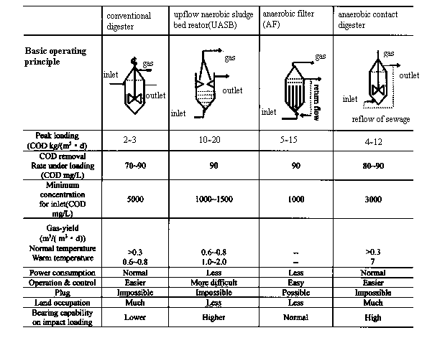
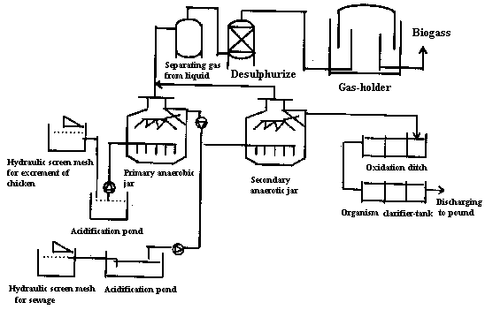

Figure 1.1 Typical technological process of large & medium-scale biogas

    - Construction
Presently large & medium-scale biogas engineering mainly adopts reinforced concrete as material in China, thus it has caused long period construction and occupied large area with difficulty on quality control. Recently an agency enterprise under Lipu Company in Germany was established in China. Using Lipu-characterized double folds and interlock technology, compound thin iron-plate with 2-4 mm thick was made into a tank or digester with 100-5000 m³ by special technical equipment. This up-to-date tank only 10% weights of reinforced concrete one with half construction cycle of concrete at same scale. Moreover the new tank is erosion resistant with long life span.
  - The status of Large & medium-scale biogas engineering
    - National development status
Presently large & medium-scale biogas engineering mainly adopts reinforced concrete
By the end of 1998 large & medium-sized biogas engineering in scale breeding farms has reached 573 nationally with total volume 147,700 m³，annual gas-yield 17.46 million m³，households supplied 36,000，biogas generation 1.01million KWh，wastes treatment 5.12 million ton as well as commercial fertilizer 130,000 tons. See Table 1.4.
The main characters on number and distribution of biogas engineering in breeding farms are as follows:
Number of biogas engineering is few. Breeding farms with biogas engineering only account for 4% of the total in China, so there is much space for the development of biogas engineering in market potential.
The distribution character of biogas engineering shares the same with large & medium-scale breeding farms. Biogas engineering is mainly concentrated in East China. The development of biogas engineering should be in keeping with the development of local economy.
Biogas is mainly used as residential fuel. Biogas generation should be improved further on technical development、demonstration and concerning policies and measures.
    - Investigation on 7 biogas engineering of breeding farms
According to the requirement of the project on-spot investigations have been carried out on 7 selected biogas engineering. Basic information about them is illustrated in Table 1.5; the detail is described in report 3. The following are concluded from the investigation:
- All 6 biogas engineering are built for treatment of pig manure except Gaoqiao Pig and Breeding farm in Songjiang in Shanghai. All biogas engineering are built with the scale of treating excrement for above 10,000 pigs except Dengta Biogas Engineering in Hangzhou which can treat pig manure for 200,000 with discharge of excrement by 185 tons and sewage by 3000 tons daily.
- All biogas engineering are built in recent years except Jingshan biogas engineering in Hubei province were built in 1991. Among them Dengta Biogas Engineering in Hangzhou is just built and will put into operation immediately after acceptance survey. In addition biogas engineering will be completed in 2001 in Hongming Pig Farm in Shanxi Province by plan.

Table 1.4 Large & medium-sized biogas engineering of breeding farms in China
in 1998
 | Number of  Plant | Total volume（10,000 m³） | Volume of treatment（10,000 tons） | Annual gas yield（10,000 m³） | Households supplied | Installed capacity(KW) | Generation （10,000 KWh） | Commodity fertilizer（10,000 tons）
Total | 573 | 14.77 | 512.23 | 1746.35 | 36329 | 601 | 101.52 | 13.17
Beijing | 10 | 0.25 | 8.05 | 29.29 | 417
Hebei | 70 | 0.35 | 3.34 | 25.51 | 190
Liaoning | 16 | 0.52 | 10.60 | 2.95
Shanghai | 32 | 2.27 | 12.68 | 631.98 | 13381 |  |  | 0.14
Jiangsu | 76 | 1.56 | 29.43 | 98.19 | 2524 | 48 |  | 1.71
Zhejiang | 47 | 1.77 | 58.00 | 385.61 | 6773 | 95 | 83.22
Anhui | 12 | 0.13 | 2.41 | 4.07 | 139
Fujian | 52 | 2.05 | 172.60 | 178.85 | 5024
Jiangxi | 36 | 0.71 | 70.60 | 58.35 | 1609 | 260 | 18.00
Shandong | 5 | 0.30 | 2.57 | 28.15 | 425 |  |  | 0.30
Hubei | 53 | 0.62 | 22.66 | 43.57 | 2683 |  |  | 0.06
Hunan | 77 | 1.48 | 40.09 | 142.46 | 1372 | 175 |  | 9.96
Guangdong | 27 | 1.05 | 6.56 | 47.06 | 587 | 23 | 0.30 | 0.90
Guangxi | 11 | 0.15 | 0.23 | 17.75 | 400
Hainan | 13 | 0.24 | 4.45 | 25.60 | 155
Chongqing | 8 | 0.15 | 15.28 | 2.99 | 346
Sichuaan | 17 | 0.45 | 51.84 | 15.49 | 250
Yunnan | 6 | 0.07 | 0.84 | 7.28 | 20 |  |  | 0.10
Shaanxi | 4 | 0.20 |  | 1.20 | 34

- All biogas engineering are built for different purposes. Gaoqiao biogas engineering of Songjiang County in Shanghai is environmental protection-oriented to treat excrement and urine of pig and chicken. It locates on the upper stream of Huangpu River that runs through Shanghai and is just 6 Km away from drink water intake for Shanghai municipality, and of course within water resource protection area in Shanghai municipal. This biogas engineering is very typical in Shanghai. Biogas engineering planned to built in the next 2-3 years are also aimed at environmental protection in Shanghai. Besides purpose of environmental protection the other 6-biogas engineering also aimed at comprehensive utilization as providing biogas and power. Quantou biogas engineering uses biogas for generation to supply the farm itself due to shortage of power feeding in local. Dulehe Orchard biogas engineering uses slurry and sludge for commercial production of organic fertilizer in additionally with annual output by 50 tons and annual output value by one million-yuan. The annual output of liquid plant-growth regulator and solid fertilizer could reach 500 tons and 5,000 tons respectively according to design. Under this circumstance biogas engineering is not only a environmental protection engineering for pollution treatment, but also a eco-agriculture engineering with good economic benefit, promoting the coordinative development of rural society、economy and environment.
- Considering capital investment most of biogas engineering were sponsored or donated by government or international organizations with no requirement of payback after operation. In fact the income from biogas and fertilizer can offer cost for normal operation. Therefore most of biogas engineering are not benefit-oriented although they can be managed as enterprise. However considering practical operation benefit of biogas engineering, suppose biogas and electricity can be sold at market price, fertilizer production & marketing can be commercialized and biogas engineering can be managed as enterprise, the commercial development of biogas engineering is feasible. Fortunately Dengta biogas engineering in Hangzhou and Hongming biogas engineering in Shanxi are paid much attention on enterprise management and commercialization during project verification (argumentation). Although Dengta biogas engineering in Hangzhou is sponsored by 20% by UNDP/GEF, investment payback and profit must be achieved after operation. Hongming biogas engineering were invested by private operator who is also the manager of the pig farm. The investor hoped to treat pollution up to the standard and gain benefit economically through biogas engineering. Obviously it must be supported by relevant policies from central government and local government to achieve the goal in recent term.

3. Benefits of large & medium-scale biogas engineering
Biogas engineering is an industrial process during which organic waste is decomposed and fermented by physiological group microbe under anaerobic condition and yielded biogas. Anaerobic digestion transform waste into Methane through function of microbe with energy conversion efficiency by 87% which is very difficult to attain by other energy conversion mode, the removal-rate of organic waste is as high as 80-90% after anaerobic digestion.
Currently a certain amount of high concentration sewage will produce in breeding farm no matter what excrement-removal method was taken. For a 10,000 pig farm using manual excrement-removal mode, the daily sewage amounts to at least 60 tons with COD16000-18000 mg/L. Taken simply aerobic biological treatment which is used for low concentration (COD300mg/L or so) municipal sewage treatment—decomposing organic waste to CO₂ and H₂O through function of aerobic microbe---dissolved oxygen must be produced with large amount of power consumption as removal 1 kg COD/ KWh. Treatment cost currently for municipal sewage is one yuan per ton or so in most of cities. Therefore aerobic biological treatment method only adapts for organic wastewater with low concentration, but obviously doesn’t adapt for treating effluent from breeding farm with high concentration due to high cost and difficulty in efficient utilization. Anaerobic biological treatment (anaerobic digestion) is a method which removes organic wastes by anaerobic digestion---- that is to decompose organic waste into CH_{4、}CO₂ and H₂O by anaerobic microbes without energy consumption, instead even generating 0.6 KWh with biogas produced from removal of 1 kg COD。

Table 1.5 Basic information of typical biogas engineering

Plant | Buildingup date | Purpose | Capital resources | Operational aspect | Remarks
1.Quantou Pig Farm in Fuzhou | 1995．01 | Pollution treatment & power supply for pig farm | Total investment has reached 1.725 million-yuan among them credit loan with discount interest and fund-raising by 87% and 13% respectively. Annual operating cost amounts to 200,000 yuan. | The biogas engineering operates normally with annual generation and benefit from fertilizer by 108,000 KWh and 107,000 yuan besides pollution treatment up to the standard. | Increase biogas and power prices; improve utilization percentage of biogas fertilizer; feasible for running as enterprise.
2．Nanshanji Pig Farm in Daxing County Beijing | 1997 | Pollution treatment & gas supply for villagers. | Total investment has reached 1.9 million yuan of which donation by British government, Beijing municipal government and fund-raising by 55.6%, 28% and 16.4% respectively; annual operating cost amounts to 76,000 yuan. | The number of pig in stock is only 30% of the planning; pollution is basically under control; annual benefit from biogas and fertilizer gets 130,000 yuan; biogas engineering operates normally. | Non-commercial operation.
3．Dulehe Orchard Pig Farm in Pinggu County Beijing | 1999 | Pollution treatment and comprehensive utilization. | Total investment has reached 5.48 million yuan of which central and local government aid and fund-raising from enterprise by 72.6%, 27.4% respectively; annual operating cost accounts for 3.3 million yuan (planning value). | Normal operation; zero discharge of sewage; biogas supply for farm itself; annual output of solid fertilizer by 50 tons; annual value by one million yuan. | Improve biogas price; improve fertilizer output; feasible for running as enterprise after 3 years.
4．Gaoqiao Pig & Poultry Farm in Songjiang County Shanghai | 1999．12 | Pollution treatment mainly | Total investment has reached 1.35 million yuan of which municipal investment, district government investment and farm fund-raising by 66.6%, 22.3% and 11.1% respectively; annual operating cost amounts to 136,000 yuan. | Normal operation; biogas supply for farm itself; annual marketing value of organic fertilizer by 383,000 yuan; pollution is under control. | Improve biogas price; commercialize fertilizer production; develop towards running as enterprise.
5．Dengta Pig Farm in Hangzhou | Have been completed will put into operation after acceptance check | Pollution treatment & power generation. | Total investment has reached 15 million yuan of which donation from UNDP/GEF, credit loan and farm fund-raising by 20%, 40% and 20% respectively; annual operating cost has accounts for 2.44 million yuan. | Being construction | Running as enterprise; investment payback except UNDP/GEF.
6．Hongming Pig-breeding Farm in Shanxi | Completion in 2001 | Pollution treatment and comprehensive utilization. | Total investment has reached 1.51 million yuan of which credit loan and farm fund-raising by 70% and 30% respectively; annual operating cost has accounts for 50,000—60,000 yuan. | Annual benefit is anticipated to 500,000 yuan. | Private enterprise; commercial management; investment payback within 3 years.
7．Jingshan Pig-breeding Farm in Hubei | 1991 | Pollution treatment & gas supply for staff. | Total investment has reached 341, 000 yuan and was raised by the plant operator with annual operating cost by 21,000 yuan. | Gas supply for over 90 households staff; partial pollution treatment. | Operation as welfare.

In summary the characters of anaerobic digestion are as follows:
- No oxygen supplies for the digestion process. This requires no equipment and power consumption for oxygen supply, which reduced the whole operating cost；
- Yielding biogas. Energy stored in pollutants is recovered through anaerobic digestion with recovery rate by 80% above；
- Comparative less amount of sewage produced. This reduced treatment cost for sewage；
- Particular biodegradability for some hard-biodegradable matter and toxic organics. Therefore anaerobic digestion technology can be converted into removing low concentration toxic matters.

Biogas project not only produces biogas but also produces digested slurry and digested sludge, which contain nutrients as growth hormone, vitamin, organic acids and amino acid. The slurry and sludge are suitable for agricultural irrigation, feeding fish and fertilizer. Since it contains no chemicals and harmful organism that were killed during biogas fermentation, digested slurry and sludge are organic fertilizer for green food production.
- Utilization of biogas
According to current industrial technology per meter cube sewage from pig farm (calculate at COD content 16,000 mg/L) generates biogas by 4 m³. Take a 10,000 pig farm for example, gas-yield of anaerobic digester amount to 400 m³ with annual output by 146,000 m³, equal to 290tce. The above gas can supply over 250 households for residential consumption with annual gaining by 175,200 yuan at the calculation of 1.2 yuan /m³. In addition used for power generation by 1.5 KWh/m³, biogas can be used for heating chicken incubation, warming livestock breeding-piggery as well as providing productive warm water.
- Utilization of digested slurry
Digested slurry contains abundant N、P、K、micronutrient and other biological active substance, it is a high quality organic fertilizer. The utilization of slurry instead of chemical fertilizer as basic manure and top application for crop has reduced chemical fertilizer consumption greatly, decreased production cost, improved output and quality of crops and promoted agricultural eco-environmental protection, for example Fushan Breeding farm in Zhejiang Province used biogas fertilizer to upgrade 200 mu low-output farmland into high output、high efficiency and quality farmland with output above one ton/mu. The consumption of chemical fertilizer has decreased from 154 kg/mu in 1988 to 45 kg/muin1991, decreasing 70.7%; the annual chemical fertilizer saved amounted to 21.8 tons for total 200 mu demonstration farmland, decreasing input cost by 17,440 yuan at the calculation of current price of 800yuan/ton. The grain output has increased from 725 kg/mu in 1988 to 962 kg/mu in 1991, increasing 237 kg/mu with growth rate by 32.7%, the annual income increased 23,700 yuan at the calculation of current price of 0.5 yuan /kg.
- Utilization of dry dung and digested sludge
Poultry manure and digested sludge contain bold protein、 bold fat、Calcium and phosphorus by 15.9%、2.2%、12% and 3.5% respectively in addition to mental elements，so they are optimum feed for fish. They also contain abundant organic and elements as N、P and K, and can be used for soil amendment, and fertilizer for orchard and flowers after direct reclamation.
Livestock and poultry manure with dry matter content about 25% were composted after manual collection, then dried and produced into granulated fertilizer, or produced into compound fertilizer added with chemical fertilizer based on demand of crops which not only reduce sewage content, but also gain benefits from selling organic fertilizer. The price of granulated fertilizer is 400－800 yuan por ton in organic agriculture areas and commercial crops area such as horticulture centralized area. In some chicken farms, dung is dried even with coal consumption by 200-300 kg per ton but they are still beneficial.
- Prospect and outlook of biogas engineering of breeding farm in China
4.1 Overall assumption for development of biogas engineering
Based on development status and environmental protection requirements of local breeding farm、natural condition and economic development status select typical breeding farm to carry out commercial demonstrative engineering project; strengthen further the macro-management of engineering design units and engineering construction units to attain standardization of designing and construction; increase further capability building for supporting system; expand the influence of biogas engineering through typical case to drive biogas engineering construction of large and medium-scale breeding farms in China with marked efficiency for pollution treatment, sound social benefits and economic benefits; establish gradually industrialized development mechanism for Energy-environment Engineering; finalize industrialization of supporting equipment production, socialization of service and commercialization of biogas engineering products through supporting relevant industries and development of service system to guide the sustainable development of scaled livestock industry.
4.2 Basic principles for biogas engineering development
- Integration of economic benefits and social benefits. Improving economic benefits of enterprise themselves through comprehensive utilization of livestock and poultry excrement and developing market for products while treating pollution；
- Invigoration of science and technology. Introducing international and domestic advanced technology and referencing successful experiences from other industries to improve pollution treatment and comprehensive utilization；
- Adaptation to local condition. Deciding the treatment mode with lowest input and high efficiency suitable for breeding farm according to geographical location and ambient environment；
- Industrialized development. Guiding breeding farm to construct and manage biogas engineering according to market mechanism; raising fund and investing according to financial laws; selling biogas、electricity and other products commercially according to cost accounting and profits.
4.3 Enhance capability building of system and perfect guarantee mechanism of marketing
- Capability building for designing and training team. Currently the technical forces of biogas engineering design units is quite weak, in addition due to restriction on capital and equipment it is difficult to accommodate biogas development for biogas engineering designing unit. Therefore it is urgent to intensify technical forces, equip with necessary research facilitation and perfect designing approaches. Meanwhile innovation and installation of necessary training facilities to strengthen training capability must perfect infrastructure construction.
- Enhancement of quality supervision and testing to safeguard capability building of team. Perfecting related testing approaches for selected units with certain base condition through innovation and installation of testing apparatus; supervising the construction quality of biogas engineering; testing all technical indicators on Energy-environment Engineering to improve the overall quality and level of biogas engineering.
- Technical innovation for enterprises specialized in industrial equipment. Intensifying production capability of supporting equipment enterprises, special equipment enterprises for energy-environment engineering to speed up commercialization of biogas engineering construction; focusing on supporting special equipment enterprise for technical innovation; expanding production scale; increasing product species and improving product quality to meet the demand of project construction.

5. Conditions and inhibition factors for biogas engineering development

5.1 Favorable conditions

（1）Basically mature technology. Complete set of biogas technology has become more and more mature gradually about biogas engineering after 20 years of researches and development, including pre-treatment、anaerobic digestion、 biogas distribution、fertilizer manufacturing as well as post-treatment for digested effluent according to differences of fertilizers as pig manure、poultry manure and cattle excrement. Some technologies and indicators have even taken a lead internationally such as biological anaerobic fermentation mechanism research、different fermentation industrial process for different excrement、gas-yield rate and COD removal rate.
（2）Successful experimental engineering. A certain number of experimental and demonstrative engineering have been built such as Spark Farm in Shanghai、Fushan Breeding farm in Zhejiang、Masanjia Pig Farm in Shenyang and Biogas Supply Station of Jiading Livestock-breeding Farm in Shanghai. All these demonstration engineering have operated successfully for over 5 years under different natural conditions and in different regions and have provided experiences for scale popularization of biogas engineering.
（3）Good basis for manage and technical service system. Presently manage and technical service team for biogas engineering has been initially established in China with researchers and designers engaged in biogas and relevant energy environmental protection in some colleges and institutions. In addition rural energy offices at central、provincial and prefecture levels have been established in recent 20 years and rural energy management organizations have even been established in some counties. Comparative complete management system has been formed during practice, providing system guarantee for development and scale construction of biogas engineering in China.

5.2 Inhibition factors for commercialization of biogas engineering
- Difficulty in investment of biogas engineering due to low profits
The initial investment is very high for biogas engineering with investment by over two million yuan for a 10,000-pig scale farm. However breeding industry profits too less to invest biogas engineering with environmental protection benefits. Moreover material for biogas engineering comes from excrement which generated from breeding farm, so biogas engineering is a post-industry depending on animal husbandry industry. The input of biogas engineering means nothing once the breeding farm losses or closes down. Therefore biogas project is a high risky investment and it is difficult to absorb enterprises to invest in it. In addition although biogas engineering is a indispensable supporting environmental protection engineering, vegetable basket project for which the mayor assumed sole responsibility benefits people directly which makes it difficult to strengthen supervision for environmental sectors, not like industrial environmental protection engineering with high pressure for construction.
- Difficulty in embodying integrated benefits of biogas engineering

1) Currently most of biogas engineering are built with main purpose of obtaining biogas while neglecting of utilization development of digested slurry and sludge; 2) Biogas engineering is a auxiliary project for breeding farm, but referential policies (preferential power prices、preferential fuel and loss subsidy) for vegetable basket project are not used in biogas engineering; 3) Although biogas engineering has contributed a lot for rural environmental protection, environmental benefits are unable to take into biogas engineering; 4) Biogas were supplied for residential consumption as a kind of welfare, not charging as quality gas fuel nor considering investment payback and profits; 5) Biogas consumption instead of coal has decreased the excavation of fossil fuel and GHG emission, however resource protection and environmental benefits are not taken into profits brought by biogas engineering.
- Weak leading policies for promoting commercialization development of energy-environment engineering by central government
（1）Investment policy. Biogas engineering belongs to efficient and integrated utilization engineering of wastes, the social and environment benefits of this item of projects are more obvious comparing with economic benefits. Definite incentive policies for investment of biogas engineering has not issued in China at present, existed investment policies were not implemented fully due to shortage of proper assessment approaches. What more key strategic research and trial demonstration research were invested less with disperse fund which inhibited the development of biogas technology.
（2）Price policies. The selling price of biogas is a key factor, which influences the economical feasibility. The present price is a welfare price. The government hasn't stipulated corresponding basis and approaches on guiding price for biogas, which couldn't make the operation mode of biogas engineering into part of market.
（3）Revenue policies. For biogas engineering without commercial operation capability while with remarkable social and environment benefits on the other hand the government only offered limited referential policies on tax presently. For example the value-added tax is divided into 2 grades currently ---baseline tax rate 17% and referential tax rate 13%---biogas engineering is charged at 13%. Still referential tax rate took less effect in promoting the development of biogas engineering due to high initial investment.
（4）Environmental protection policies. Environmental pollution problem brought by large and a medium-scale breeding farm is not neglectable. Pollution fine and punishment for breeding farms are quite different by areas, but it will become more severe and sterner in term of trend. Therefore it is urgent for government sectors to carry out research and stipulate policies on how to promote biogas engineering development by using environment policies and how to fully utilize pollution discharge fee.

Report 2. Investigation on Biogas Plant Development in Urban Breeding farms

According to the demand of project Investigation on Biogas Plant Development in Urban China, investigation should be made in 2~3 cities. Therefore, project members have visited three cities, Beijing, Shanghai and Hangzhou, to collect material. Corresponding local experts are also invited to join the investigation and they have provided, according to the outlines (see annex) designed by the project team, some material on biogas plant development in these 3 cities. Project members arranged and analyzed the material and completed 3 reports, shown in the following table 2.1.

Table 2.1

No. | Report | Author
Case 1 | Investigation on the Development of Biogas Plants in Breeding Farms in Shanghai | Jin Yao, Director of Shanghai Municipal Rural Energy Office
Case 2 | Investigation on the Development of Biogas Plants in Breeding Farms in Beijing | Zhou Mengjin, Professor, Capital Normal University
Case 3 | Investigation on the Development of Biogas Plants in Breeding Farms in Hangzhou | Cai Changda, Director of Hangzhou Municipal Rural Energy Office

Case 2.1: Investigation on the Development of Biogas Plants in Breeding Farms in Shanghai

- General Situation of Outskirts and Energy Supply

Shanghai is located in the Yangtze Delta, the middle of China’s South-North coastline. Total area of the city is 6340km² and total population more than 13 million. Besides downtown, Shanghai also includes 7 suburban districts and 3 outer suburban counties. With the deepening of reforms and widening of opening-up, all trades in the outskirts are developing rapidly and the outskirts has become the base of subsidiary foodstuffs, foreign exports, traffic and residential subzones, etc. Furthermore, the construction of modern infrastructures in downtown has also promoted the construction of energy infrastructures (electricity, fuel gas and heating power) in suburbs and outer suburbs. This can satisfy to a large extent the newly increased energy demand in rural areas. Currently, all process and domestic energy used in the suburbs is commercial energy supplied by the market and domestic energy used in rural areas has shifted from non-commercial energy, such as crop straw, to conventional commercial energy, such as coal, oil and electricity.

- Development of Breeding farms

In 1990, the output of stockbreeding in Shanghai was 3 billion-yuan. In 1997, it increased to 8.8 billion, with an annual increase of 16.6%. This has contributed greatly to enrich the residents’ “Vegetable Basket”. According to statistics in 1999, the amount of dairy cattle on hand in Shanghai’s outskirts was 44,700 and live pig 4.5 billion, and 57.8 million fowl were supplied to the market. According to the scale of 100 dairy cattle, 1000 pig or 10000 fowl in one breeding farm, there are 1600 large and medium-scale breeding farms in Shanghai. Among these, 439 farms are large-scale ones with scale larger than 5000 pigs, 30000 fowl or 100 dairy cattle in one farm. See table 2.2 for details.

Table 2.2 Distribution of Large-scale Breeding Farms in Shanghai

County (district) | Pig farm | Layer farm | Dairy cattle farm | Total
Minhang District | 21 | 3 | 4 | 28
Jiading District | 30 | 6 | 8 | 44
Baoshan District | 24 | 4 | 15 | 43
Pudong New District | 15 | 4 | 5 | 24
Nanhui County | 17 | 3 | 12 | 32
Fengxian County | 28 | 7 | 11 | 46
Songjiang District | 33 | 5 | 10 | 48
Jinshan District | 25 | 11 | 36 | 72
Qingpu District | 26 |  | 10 | 36
Congming County | 6 | 14 | 9 | 29
Agriculture, Industry and Commerce | 10 | 3 | 23 | 36
Institute of Agricultural Sciences | 1 |  |  | 1
Total | 236 | 60 | 143 | 439
According to statistics, the annual amount of discharged excrement from large and medium-scale breeding farms in Shanghai’s outskirts is more than 7.4 million tons. Restricted by fund, equipment treating excrement and waste was not built in many breeding farms in the early stages of farm construction. So discharged excrement cannot be properly treated. According to investigation, about 80% of livestock and fowl excrement are utilized currently by various means, whereas as much as 50% of urine and rinsing water has leaked. The leaked waste flows directly into ground river course and thus results in serious environmental pollution.
From early 1990’s, governments at all levels, from the municipality to villages and towns, began to construct, jointly with breeding farms, livestock and fowl excrement treating projects to control environmental pollution resulted from excrement discharged from breeding farms. Up to 1997, 94 treating projects had been built, of which 19% are biogas plants. In biogas plant, livestock and fowl excrement is fermented with anaerobic digestion technology and then immited into oxidation ditch. Finally, the waste is discharged when it reaches the discharge standard. Currently, dry material of excrement is, after anaerobic digestion, made into organic fertilizer. So pollution resulted from excrement can be prevented to a large extent. Whereas, due to the large initial investment of urine treating equipment and high operating cost, the discharged urine cannot fully reach the discharge standard.

- Development of Biogas Plant

According to estimation, about 328.34-million m³ biogas can be generated from livestock and fowl excrement in Shanghai. This is equivalent to the quantity of heat of 0.33 million tons of standard coal. See table 2.3 for details.

Table 2. 3 Potential Biomass Energy Contained in Livestock and Fowl Excrement in Shanghai

Type | Amount on hand  (1000) | Biomass energy (biogas) (1000 m³/year) | Standard coal  (ton)
Dairy cattle | 44.4 | 15,585.0 | 15,585.0
Live pig | 3,315.0 | 302,512.0 | 302,512.0
Layer | 3,775.0 | 10,585.0 | 10,585.0
Other fowl | 85,898.0 | 660.8 | 660.8
Total |  | 329,342.8 | 329,342.8

As one of the main methods to dispose livestock and fowl's excrement as well as wastewater, biogas plant has been put into operation in Shanghai since 1980’s. Since 1991, Shanghai Municipal Agricultural Commission, Municipal Environmental Protection Bureau and Financial Bureaus of each district and county have appropriated annually about 9 million yuan to prevent pollution resulted from livestock excrement and urine. Up to now, treating equipment has been built in 94 breeding farms of which 17 are biogas plants. Furthermore, biogas plants have been built in 13 other breeding farms, with financial support from other sources. According to a recent investigation, in these 30 biogas plants, 6 have stopped operation or shifted to other treating method, one is in poor operation and the other 23 are in normal operation.
Biogas plants are mainly built in large- and medium-scale breeding farms with scale larger than 5000 pigs, 100 dairy cattle or 20000 fowl. These biogas plants mainly center in outskirts with developed economy and state-operated farms. According to an investigation on the 17 biogas plants in Shanghai, the investment of each plant is 0.39-3 million yuan, with an average of 0.9816 million yuan.
After more than 10 years, large- and medium-scale biogas plants in Shanghai are now developing steadily and healthily. Raw material for treatment of these plants includes organic industrial wastewater, agricultural waste and sanitary waste, etc. Raw material for fermentation of these plants is mainly livestock and fowl excrement, and perfect mixture technology is used in most plants. In the early 1980’s, fermentation equipment was underground pressure biogas tank with unit volume of 50 m³. Such type of biogas has the characters of normal temperature fermentation, long retention period and low gas productivity. In later 1980’s, an improved technology, with agitating device, sludge return-flow device as well as ground biogas tank with insulating device, was used in biogas plants. With the improved technology, the biogas productivity can be increased to about 1.2-2.0 m³/m³⋅day. In recent years, with the development of "vegetable basket" in cities and large-scale breeding, raw material treating equipment and up-flow sludge blanket for excrement are also added before anaerobic digestion process. This has improved biogas productivity and the COD removal rate can reach 85%.
Material after anaerobic digestion is high-quality organic fertilizer and can be made into regenerated feed. In order to fully utilize the material and improve the economic benefit of biogas plant, solid-liquid separating machine is used to separate the digestion liquid and make granular fertilizer and feed. This technology can non only improve the economic benefit of biogas plant, but also supply high-quality fertilizer and regenerated feed for agriculture, flower market and livestock breeding.
Before 1980, few biogas plants, which treat cattle excrement with anaerobic digestion technology was built in breeding farms with scale larger than 1000 cattle. In 1990, the Star Farm built, jointly with Shanghai Industrial Microbiology Research Institute and Shanghai Town and Country Architecture Institute, a large-scale biogas plant utilizing excrement of more than 2000 dairy cattle in the farm. The plant was completed at the end of 1991 and consists of 6 fermentation ponds with each volume of 450 m³, biogas storage tank of 1400 m³ and pipeline. The average gas productivity is 1.2 m³/m³⋅day and the highest can reach 1.93 m³/m³⋅day. The plant can treat annually 31,000 tons of cattle excrement, 4380 tons of fowl excrement and 3000 tons of industrial organic waste. Biogas produced from the plant can satisfy the need of 3000 households in the farm and 70% of the households in the farm then began to use pipeline biogas. Therefore, 3140 tons of coal can be substituted annually and this has reduced greatly pollution resulted from bituminous coal.
The Star Biogas Plant discharges 150 tons of fermentation residues every day and this will result in secondary environmental pollution if it cannot be treated properly. Many measures have already been adopted to prevent the pollution. Firstly, the excrement transfer pipeline is used to transfer biogas fluid to cropland and about 100 tons of biogas fluid can be disposed with this method. With the use of biogas fluid in cornfield, the rate of emergence increases by 21% and yield 28%. With the use of biogas fluid in melon field, the sugar degree of watermelon increases by 20%. At the same time, a large amount of pesticide and fertilizer has been saved. Secondly, the left biogas fluid is delivered, with tank car, to cropland and fishpond that pipelines cannot reach. Thirdly, biogas sludge is separated from the fluid and then made into greens nutritive block or fish feed. This can increase the economic benefit of biogas plant.
After the construction of large-scale biogas plant in the Star Farm, not only environment in the diary cattle farm is greatly improved, but also clean and convenient high-quality energy is produced. It can be seen that biogas technology can not only improve surrounding environment and reduce the spreading of diseases, but also can improve the fertility of soil. So the economic as well as social benefit of biogas technology is remarkable.
Another biogas plant built in Baoshan District Vegetable Garden Spot can treat annually more than 3000 tons of pig manure. The plant’s rated daily capacity is 990 m³ biogas and by the end of 1999, 846,800 m³ of biogas, 1877.14 tons of biogas slag and 16,425 tons of biogas fluid have been produced.

- Relevant Government Policies and Measures

Breeding farms in Shanghai have contributed greatly to Shanghai residents’ daily life. Therefore, the municipal government has formulated some supportive policies to assure breeding farms’ meager profit. At the same time, supportive policies are also necessary for the healthy development of biogas plants.
In the last decade, Shanghai Municipal Government as well as subsidiary district and county governments have invested approximately 70 million yuan in the treatment of livestock waste. Almost all of the biogas plants built in breeding farms have received necessary subsidy from the government.
In China, there’re a series of laws and regulations that are related to pollution prevention and abatement. Shanghai Municipal Government released Shanghai Municipal Stipulation on Prevention and Abatement of Pollution Resulted from Livestock and Fowl on March 7th, 1995 and then it came into practice from May 1st of the same year. There’re detailed demands in the stipulation for newly built breeding farms in aspects such as waste discharge standard, discharge license, charge for waste discharge, penalty, etc. Whereas, due to the importance of livestock and fowl breeding to the daily life of residents and lack of environmental protection consciousness, etc., the stipulation has not been well implemented.
In order to solve these problems, Shanghai Municipal Government formulated a new plan for the treatment of livestock and fowl excrement, in 1992. In order to implement this plan, Shanghai Municipal Leading Group for the Comprehensive Treatment of Livestock Excrement was founded and the group consists of Shanghai Municipal Planning Commission, Agricultural Commission, Environmental Protection Bureau, 10 county (district) governments as well as Group of Agriculture, Industry and Commerce. The leading group on one hand has formulated clear and effective principles, guidance and methods for the comprehensive treatment of livestock excrement in Shanghai, on the other hand has implemented strictly relevant laws and regulations. Therefore, pollution resulted from excrement from large and medium-scale-breeding farms in Shanghai’s outskirts has been effectively abated.
According to the geographic position of Shanghai and the distribution of breeding farms in outskirts, the leading group has divided the whole city into 3 types of regions and formulated specific countermeasures for each type of region. The group has determined that 4 years will be used to abate the pollution and in the end, a new and logical framework of livestock and fowl breeding in Shanghai’s outskirts, with less than 1000 breeding farms which can reach the discharge standard, will be formed.
In 1999, 110 breeding farms were listed as key treating projects of the whole city, of which 50 farms were key projects of the municipal government, and the construction of 2 organic fertilizer treating centers were planned. Total investment of these 112 projects is 114 million-yuan. Thanks to the efforts made by various departments, some actual progresses were made in the comprehensive treatment of excrement in 1999. By December 20th, 1999, the civil work as well as installation and adjustment of equipment in the 50 farms which are the municipal government’s key projects had been finished in advance and the percent of pass is 100%. When the 110 treating projects in breeding farms have been completed, about 39,800 tons of COD and 6480 tons of NH₃-N will be reduced. Furthermore, 400 other breeding farms resulting in serious pollution were closed in 1999.
Shanghai Sanxing New Energy and Environmental Protection Company is an enterprise mainly specializing in large- and medium-scale treating projects for livestock and fowl excrement as well as industrial high-density organic waste water. In recent years, the company has been involved in the feasibility study, engineering design, project construction of more than 10 waste treating projects and concerned staff training and technical services. Table 2.4 and 2.5 show respectively some of the biogas plants that the company undertook and completed in year 1999 and 2000.

Table 2.4 Biogas Plants in Breeding Farms in Shanghai Built in 1999

No. | Unit | Scale | Anaerobic Tank  (m³) | Biogas Tank  (m³)
1 | Pudong New District Heqing Dairy Cattle Farm | 600 | 700 | 200
2 | Chaoyang Dairy Cattle Farm | 800 | 500 | 100
3 | Luchaogang Dairy Cattle Farm | 800 | 500 | 100
4 | Xinghuo Qilin Breeding farm | 10000 | 300 | 50
5 | Jinshan District Luxiang Fowl Farm | 80000 | 300 | 100
6 | Jinshan District Tinglin Seed Stock Farm | 16000 | 300 | 50
7 | Jinshan District Zhangyan Seed Stock Farm | 12000 | 300 | 50
8 | Jinshan District Ljxiang Seed Stock Farm | 16000 | 300 | 50
9 | Songjiang District Gangqiao Breeding Farm | 10000 pigs and 30000 fowl | 300 | 100
10 | Songjiang District Dairy Cattle Farm | 600 | 300 | 100
11 | Songjiang District Maogang Seed Stock Farm | 10000 pigs and 32000 fowl | 350 | 100
12 | Songjiang District Huinong Seed Pig Farm | 12000 | 300 | 50
13 | Songjiang District Bainiao Seed Stock Farm | 12000 | 300 | 50
14 | Songjiang District Seed Stock Farm--- north part | 12000 | 400 | 100
15 | Songjiang District Seed Stock Farm --- Seed Pig Farm | 12000 | 300 | 50
16 | Songjiang District Zhangze Seed Stock Farm | 12000 | 200 | 100
total |  |  | 5650 | 1350

Table 2.5 Biogas Plants in Breeding Farms in Shanghai Built in 2000

No. | Unit | Scale | Anaerobic Tank  (m³) | Biogas Tank  (m³)
1 | Fengxian County Shenlan Pig Farm | 23000 | 300 | 100
2 | Fengxian County Jinhui Seed Stock Farm | 8000 pigs and 20000 fowl | 300 | 100
3 | Fengxian County Xidu Seed Stock Farm | 12000 | 300 | 100
4 | Jinshan District Miaojing Seed Stock Farm | 20000 | 300 | 100
5 | Jinshan District Jiankang Dairy Cattle Farm | 300 | 300 | 50
6 | Songjiang District Ruxin Seed Stock Farm | 12000 | 300 | 50
7 | Songjiang District Wuhudang Seed Stock Farm | 10000 | 300 | 50
8 | Songjiang District Wufeng Dairy Cattle Farm | 350 | 300 | 50
9 | Songjiang District Wulitang Pig Farm | 18000 | 550 | 100
10 | Songjiang District Jiuting Pig Farm | 12000 | 300 | 50
11 | Songjiang District Xinle Pig Farm | 8000 | 300 | 20
12 | Songjiang District Litahui Pig Farm | 12000 | 300 | 20
13 | Songjiang District Xinmin Pig Farm | 12000 | 300 | 20
14 | Songjiang District Gonggang Pig Farm | 20000 | 500 | 100
total |  |  | 4650 | 910
- Development and Action Plan

Large- and medium-scale biogas plant using anaerobic digestion technology has become one of the effective methods to treat and utilize livestock and fowl excrement. In Shanghai, the whole set of technology is becoming mature gradually. Currently, the demand from environmental protection is the main impetus for the development of biogas plants. Shanghai Municipal Planning Commission has already formulated development plan for new and renewable energy in the 10th Five-Year-Plan and through 2010. It is put forward in the plan that in the next five years, more biogas plants using rather mature technology should be built, design, technology and automatic control level of biogas plant should be improved, and livestock and fowl excrement should be utilized with resource technology.

Demonstrative Biogas Projects in 2001-2005
Project Type: comprehensive treatment of livestock and fowl excrement as well as wastewater
Project Objective: to build 2 high-level demonstrative energy-environment projects that can treat excrement and sewage from farms with scale of 1000 cattle, 10000 pigs or 100000 fowl. Generated biogas will be used for power generation and the discharged fermentation fluid will reach relevant standard.
Production Scale: One demonstrative project is capable of treating 15,000 tons of pig excrement and waste water (waste from 20000 pigs), 10000 tons of fowl excrement (waste from 300,000 fowl) and 20,000 tons of cattle excrement (wastes from 1000 cattle), generating 4.2 million m³ of biogas and 8 GWh electricity, in one year.
Equipment Scale: anaerobic digestion equipment: 2000 m³×4×2; biogas tank: 1000 m³×4×2; power generating sets: 500 KW×4×2; 2 sets of solid-liquid separator, 2 sets of automatic managing equipment.
Technology: German technology will be introduced to manufacture anaerobic digestion equipment; high-efficiency biogas power generation equipment will be introduced from Austria; high-efficiency composite microbe developed by Shanghai Environmental Bioengineering Company will be used.
Investment and Capital Source: Investment of the 2 demonstrative projects is about 70 million yuan, of which 20 million is for supporting facilities, 30 million for equipment, 15 million for introduction of technologies and 5 million for project management and services. Investment comes from government allotment, loan-interest loan, self-raising, etc.
Profit Analysis: profit of the 2 projects includes: a. Annual treatment of excrement and waste water from 40000 pigs, 600,000 fowl and 2000 diary cattle, b. Annual production of more than 8.4 million m³ of biogas which can then be transferred into electricity of more than 16 GWh. Waste heat will be fully utilized to assure the normal operation of the equipment in the whole year, c. Discharged fermentation liquid will reach standards for COD, NH₃-N, BOD and PH Value; d. More than 7000 tons of fertilizer can be obtained and if it is used in cropland and flower plantation, the added value will be 4 million yuan; e. Demonstration for the operation of new technology and new equipment.

- Barriers for the Commercial Development of Biogas Plant
1. Currently, there’re few policies and regulations promoting the commercial development of biogas plant. Social and environmental benefits of biogas plant are very obvious, while rate of return is rather low. Up to now, there is no supportive policy in Shanghai promoting the commercial development of biogas plant and this has greatly affected the enthusiasm of investors.
2. Compared with foreign anaerobic digestion technology, domestic biogas plant is backward in equipment manufacture, automatic control and operation, etc. Furthermore, there’s no standard for the manufacture of main equipment and project construction and this has also restricted the further development of biogas plant.
3. Biogas plant is a commonweal industry, featured by rather high initial investment and low economic benefit. Furthermore, the economic benefit of livestock breeding is rather low. So difficulty in fund raising has affected the commercial development of biogas plant.

- Suggestions

In order to control the environmental pollution resulted from breeding farms, State Administration of Environmental Protection, Ministry of Agriculture and State Technical Supervision Bureau have jointly formulated Discharge Standard for Excrement and Waste of Livestock and Fowl Breeding as well as Regulation for Prevention of Pollution Resulted from Livestock and Fowl Breeding, and will release these standard and regulation in the near future. This will promote greatly the treatment of livestock excrement.
In the very beginning, the main purpose of building large- and medium-scale biogas project is to produce biogas and solve energy shortage in rural areas. In 1990’s, large- and medium-scale biogas project technology was used to treat livestock and fowl excrement and abate environmental pollution, in Shanghai. Therefore, the purpose of building large- and medium-scale biogas project has shifted from energy production to environmental protection and comprehensive utilization of biogas, biogas fluid and biogas slag. This is fully reflected in the biogas plants that are now being constructed in Shanghai. In order to promote the commercial development and operation of biogas plant, following suggestion are put forward.
- Formulate relevant laws and concerned detailed rules for implementation
The government should formulate supportive policies, from the viewpoint of rational resource exploitation, environmental protection and sustainable development. Different measures such as policy guidance, restriction by regulations and macroeconomic control, etc., should be used to promote the development of large- and medium-scale biogas project.
- Formulate clear development plan
- Formulate economic stimulative policy
Economic stimulative measures are very important to the commercialization of biogas technology and improvement of its economic competitiveness. Economic measures can be reflected in aspects such as tax, loan, investment, price and subsidy, etc.
- Investment subsidy
Subsidy from the municipal government, for demonstrative biogas project and biomass energy utilization project ,will inevitably promote the development of biogas technology.
- Preferential price
Price of electricity supplied to the electric network from biogas project can be determined to be the average retail price, and the government will subsidize the price difference. This will promote the commercial development of power generation project using biogas.
- Preferential tax
In many countries, preferential tax rate is given to investment in renewable energy equipment or purchase of renewable energy products. It will favor the development of biogas plant if Shanghai can apply preferential tax rate in the development and use of biogas technology.
- Low-interest loan
- Application of Polluters-Pay-Principle
- Promote the formation of biogas plant industry and technical service system
A perfect technical service network is necessary for the further development of biogas plants. Professional staffs and standard services are necessary for technical consultation, engineering design, quality assurance, daily maintenance, etc.
- Conduct international cooperation as well as introduce advanced technology and foreign fund
In order to improve technology used in large- and medium-scale biogas plants and promote the commercial development of biogas projects, foreign advanced technologies and key equipment should be introduced and digested selectively and purposely. At the same time, international cooperation and exchange should be promoted and foreign capital can also be introduced.

Case2.2: Investigation on the Development of Biogas Plants in Breeding Farms in Beijing

I. Background

- General Situation of Beijing
Beijing is the capital and also the political, cultural and economic center of China. Total area of the city is 16,800 km², of which 1,283 km² area belongs to outskirts, 15,400 km² area outer suburban district and 3,424km² area cultivated land. Total population of Beijing is more than 12 million, of which 3.63 million people are peasants, about 30% of the total. In 1999, the city’s GDP was 217.45 billion yuan (current price), of which 8.75 billion yuan was the total output of agriculture, just 4% of the total.
After the implementation of reform and opening-up policies, animal husbandry in Beijing has been developing very rapidly. Output of meat, egg and milk has increased greatly and now can fully satisfy the residents’ demand. The annual number of cattle, sheep and pigs for sale is 0.11 million, 0.71 million and 3.54 million respectively. The output of egg, table poultry and milk has exceeded 240,000 tons, 60 million and 230,000 tons. This not only can satisfy the demand of Beijing’s residents, but also can supply about 10% of the total output to other areas. Another feature of Beijing’s animal husbandry is that many new technologies have been used and the breeding scale is increasing gradually. For example, more than 85% of the pigs in the market are supplied by large and medium-scale breeding farms. Currently, livestock and fowl breeding are developing rapidly in Beijing.
- Environmental Situation of Breeding Farms
In recent years, with the implementation of “Vegetable Basket” project, more and more intensive and large breeding farms begin to appear. According to investigation, more than 2000 breeding farms in Beijing discharge annually 5.185 million tons of excrement and 11.931 million tons of urine and wastewater. Most of the waste is discharged without treatment, and COD density of the discharge waste is more than 50 times of the standard and BOD more than 70 times. This has become the largest resource of organic waste in Beijing. The discharged waste not only affects environment of the farms themselves, but also pollutes ground water and affects the daily life of ambient residents.
Although livestock and fowl excrement is a pollution source, it is also exploitable biomass resource. Through treatment and process, excrement can be converted into useful feed, fertilizer and fuel. In as early as 1950’s, Germany, Japan, USA and former Soviet Union began to treat urban waste water and excrement with anaerobic and aerobic technology as well as flashing baking, etc. Biogas plant treating excrement with anaerobic digestion technology can bring various types of profits such as environmental protection, energy production and economic benefits, so it has already become one of the indispensable supporting projects of China’s large breeding farms.
After solid-liquid separation, anaerobic and aerobic digestion and comprehensive utilization, discharged liquid of biogas plant can reach China’s first level discharge standard. This can greatly improve the ecological environment of project area.
Biogas plant can also produce high-grade energy -- biogas. 5~7 m³ of biogas can be produced from 1 m³ of wastewater of pig farms. A biogas plant using the wastewater from a farm of 10000 pigs can produce 550 m³ of biogas each day and this can satisfy the daily domestic energy demand of 300 peasant households. This will greatly improve the cooking condition of these households.
The disposal of excrement can improve the living condition of livestock and fowl, and thus will reduce the disease rate of animal, increase the number of animals for sale and improve the quality of livestock and fowl product. It is reported in some material that the above mentioned improvement can increase the farm’s income by about 10%. Furthermore, biogas plant can reduce environmental pollution and thus can reduce farm’s cost on environmental penalty. Biogas plant can also produce high-quality organic fertilizer and feed additive from biogas slag and biogas liquid, and therefore can increase the farm’s economic benefit.

II. Development of Biogas Plants

Biogas plants in Beijing can be roughly divided into the following types.
- Biogas plants in breeding farms, including plants using poultry excrement, pig excrement or slaughterhouse water as raw material.
In Daxing County Liuminying Ecological Farm, 2 medium-scale biogas plants using poultry excrement as raw material have already been built. One is a high-temperature biogas project, of which the volume of biogas tank is 100 m³ and gas productivity is about 2 m³/m³⋅day. The other is an intermediate temperature biogas project, of which the volume of biogas tank is 200 m³ and gas productivity is about 2 m³/m³⋅day.
Some intermediate temperature biogas projects using pig excrement as raw material have also been built in Beijing. These projects include: Fangshan District Nanhanji Village Biogas Plant, of which the volume of biogas tank is 370 m³ and gas productivity is 1 m³/m³⋅day; Fangshan District Sanjie Village Biogas Plant, of which the volume of biogas tank is 500 m³ and gas productivity is 1 m³/m³⋅day; Pinggu County Nandulehe Pig Farm Biogas Plant, of which the volume of biogas tank is 100 m³ and gas productivity is 1.2 m³/m³⋅day; and Shunyi County Zhangxi Village Biogas Plant, of which the volume of biogas tank is 200 m³ and gas productivity is 1 m³/m³⋅day.
Example of biogas plants using slaughterhouse water as raw material in Beijing is the biogas plant built in Shunyi County Meat Packing Plant, which can treat 1500 m³ of slaughterhouse water each day, and of which the volume of anaerobic digestion tank is 1200 m³ and gas productivity is 0.5~1 m³/m³⋅day.
- Biogas plants using industrial organic waste water as raw material
These plants include (a) Changping County Brewery Intermediate Temperature Biogas Plant. This project uses organic wastewater as raw material, the volume of biogas tank is 1000 m³ and gas productivity is 1.5 m3/m³⋅day. The produced biogas is used as boiler fuel of the brewery. (b) Wangzhihe Fermented Bean Curd Factory biogas plant. This project is an intermediate temperature one using wastewater of bean products as raw material. The volume of the biogas tank is 1600 m³ and gas productivity is 1.5 m3/m³⋅day. Part of the produced biogas is supplied to households and part supplied to nursery of the factory. (c) Beijing Beer Factory biogas plant. This plant is a normal temperature one treating wastewater of beer production with UASB technology. Volume of the biogas tank is 2000 m³ and gas productivity is 2~3 m³/m³⋅day. The produced biogas is used as boiler fuel.
Up to now, there’re only 6 biogas plants that are in normal operation in the whole city’s more than 2000 breeding farms and the total volume of biogas tank is 2670 m³.

III. Technologies Used in Biogas Tank (Anaerobic Digestion Tank)

In the middle 1970’s, most of the biogas tanks built in Beijing were household hydrostatic ones with unit volume of about 8 m³ and the produced biogas was used as domestic fuel for peasant households. With the appearance of small-scale breeding farms, the volume was enlarged to about 50 m³, and, livestock and fowl excrement was used to produce biogas. From the 1980’s, many researches on fermentation technology have been conducted in China, and great progress has been made in both fermentation technology and its actual application in biogas projects.
Up to now, anaerobic digestion technologies used in biogas plants can be mainly divided into 4 types: plug flow reactor (PFR), upflow solids reactor (USR), upflow anaerobic slag bed (USAB) and UBF.
PFR is a kind of rectangular non-perfect mixture reactor. High density suspended solid raw material for fermentation comes in from one side and is discharged from another side. Advantages of the reactor are that no mixing is needed, structure of the reactor is simple, and energy consumption is low. It is suitable for treating high SS wastewater, especially anaerobic digestion of cattle excrement. Its weaknesses are that the solid are prone to deposit on the bottom of reactor which will affect the effective volume of reactor, efficiency is low, back flow of solid and microbe is needed, and temperature inside the reactor is nor consistent because of the large area and volume. This reactor was used in Liuminying high temperature biogas project.
USR is simple in structure and suitable for treating high density suspended solid raw material. Raw material comes into the reactor from the bottom and comes into contact with active sludge, and then is fermented. Supernatant fluid overflows from the upside and this can greatly prolong solid residue term (SRT) and microbe residue term (MRT), and, thus increase the resolution rate of solid and efficiency of reactor.
USR technology is used in all the reactors of Liuminying intermediate temperature biogas project, Liulihe biogas project, Nanhanji and Nandulehe River biogas project. Operation of the reactors is stable and the effect is rather good.
UASB was developed by Lettinga, etc., between 1974~1978, and is the fastest developing reactor in the world. This reactor is featured by simple structure, low operating cost and high efficiency ,and, is suitable for treating soluble waste water with low density suspended solid. UASB is the most popular technology in fermentation projects in recent year and usually used in the anaerobic digestion of industrial wastewater and sanitary waste. It is used in Beijing Beer Factory biogas plant, which has been appointed key project for extension by State Administration for Environmental Protection.
UBF is a combination of UASB and anaerobic filter. Efficiency of this kind of reactor is rather high, but the cost is also higher. UBF technology is suitable for the anaerobic digestion of low density suspended solid wastewater and is used in Shunyi Meat Packing Plant biogas plant.

VI. Analysis of Fermentation Project

Anaerobic digestion tank (i.e. biogas tank) is the main part of biogas plant. Besides this, a series of supporting facilities are also necessary for the stable operation of biogas plant. A complete biogas plant should include: pretreatment of excrement and waste water; anaerobic digestion tank; purification, storage and utilization of biogas; production of solid or liquid organic fertilizer as well as biological active fertilizer; and the up-to-standard discharge of waste water.
According to the situation and purpose, biogas projects can be divided into 2 types: ecological type and environmental protection type. Process flow of these 2 types of biogas projects is shown in figure 2.1.
The difference between ecological type biogas project and environmental protection type one is the difference in the treatment of biogas liquid after anaerobic digestion. In ecological type biogas project, biogas liquid is finally used as fertilizer or feed in cropland, fishpond or water inhabiting plants pond. This type of project is in accordance with the principles of ecological agriculture and has achieved the comprehensive utilization of biomass energy and “zero discharge” of excrement. It is suitable for breeding farms where there's cropland or fishpond nearby. For other breeding farms, the discharged water should reach relevant environmental standard. Therefore, waste water after anaerobic digestion and deposition should also be treated with aerobic and physical-chemical methods. Environmental protection type biogas project is suitable for outskirts of large and medium cities. In this type of biogas plant, quality of discharged water is rather good, whereas the investment and operating cost is higher. Shunyi Meat Packing Factory has adopted this mode.

V. Development Plan of Biogas Plans in Beijing
- Plan for 2000-2010
According to the plan for biogas plants development during year 2000 and 2010 made by Ministry of Agriculture, and the reality of Beijing, 137 biogas plants will have been built by year 2010. This means 12% of the excrement in the whole city’s breeding farms will be treated. Projected total investment of these 137 projects is 350 million-yuan, of which most will be allotment from the government and loan.Project owners themselves will also raise a small part.
- Advantages to achieve the goal
- Rather mature biogas technology
Compared with other provinces and cities, Beijing is a later comer in the research of biogas technology treating livestock and fowl excrement. After more than 10 years development, especially after the successful design, construction and operation of several pilot biogas projects treating pig and poultry excrement, Beijing has already mastered several technologies related to biogas plant. Beijing is now even advanced in some single technologies and indexes, such as: research on the mechanism of biological anaerobic digestion, adoption of fermentation technologies for different types of excrement, biogas productivity, COD removal rate, etc. Therefore, Beijing has already the technical foundation for the large-scale development of biogas plants.
- Rather perfect managing and technical service groups
In Beijing, perfect managing and technical service groups have already been formed in all biogas plants that are in good operation. After the completion of construction, a managing and technical service group of 4~5 people was set up in Daxing County Liuminying Village biogas plant. In order to improve their technical ability, Beijng Municipal Rural Energy office has invited related biogas experts to give lessons to them for many times. Therefore, Liumingying biogas plant has already been operating normally for 8 years.
- Assurance from relative policies, laws and regulations
The Chinese Government and Beijing Municipal Government have attached great importance to environmental protection and utilization of new energy, and have formulated corresponding policies, laws and regulations. This has provided a favorable environment for the development of biogas plants in Beijing. It is mentioned in Some suggestions on the Active Development of Environmental Protection Industry released by the State Council in 1990 that environmental protection industry include ecological agricultural project, biogas project and comprehensive utilization technology for agricultural residues, etc. It is also clearly pointed out in Decision of the State Council to Further Strengthen Environmental Protection released in the same year that protection and improvement of producing and ecological environment as well as prevention and abatement of pollution and other public nuisance is a basic policy of China. Ministry of Agriculture released in 1996 Notification to Accelerate the Construction of Energy-Environment Projects. State Environmental Protection Administration, Ministry of Agriculture and State Technical Supervision Bureau have jointly formulated Discharge Standard for Excrement and Waste of Livestock and Fowl Breeding as well as Regulation for Prevention of Pollution Resulted from Livestock and Fowl Breeding, which will be released in the near future.

VI. Measures for Implementation

In order to achieve the development goal for biogas plants, Beijing has already implemented some specific measures.
- Strengthen guidance and clarify responsibility
Construction of biogas plants has already been listed on the agenda of the municipal government and it is requested that relevant departments and county (district) governments attach great importance to the construction of biogas plants and formulate specific developing and managing measures.
- Formulate relevant laws and regulations
Up to now, there is no law or regulation in Beijing which is related to biogas plant in breeding farms. The municipal government will formulate and release supportive financial, investment and loan policies for the development of biogas plant in breeding farms, according to relevant state laws and regulations, experiences of other provinces and cities and the demand of Outline of New and Renewable Energy Laws formulated jointly by State Planning Commission, State Science and Technology Commission and State Economic and Trade Commission.
- Raise actively funds and increase investment
In order to support the development of biogas plants, the municipal government will increase corresponding investment gradually. At the same time, some policies and measures have been implemented in Beijing, to attract investment in biogas plants from relevant enterprises and to increase the economic benefit of biogas projects. The release of these policies means the biogas plant is now moving towards the way of commercial development.
- Give broad publicity and improve the whole people’s consciousness
Public media such as televisions and newspapers should be used to emphasize the importance of biogas plants, in order to gain attention and support from the government and the people.
- Pay attention to technical progress and increase economic benefit
Scientific and technical advantages of Beijing should be fully utilized to strengthen the conversion of biogas technology to actual productivity and increase the economic and environmental benefit of biogas plants.
Barn and fowlery
Biogas
Separation of solid and liquid
Waste water
Stack retting
Mixture with other material
Baking

Prilling
Packing and sale
Anaerobic digestion
liquid
Solid

Production of organic fertilizer
Purification
equipment
Deposition
pond
Storage tank
Storage
pond
Central gas supply
Power generation
Fish pond
Water plant
pond
Cropland
Aerobic treatment
Up-to-grade
discharge of waste water
_{eerere ereree}
Environmental protection type
Ecological type
Figure 2.1. Process Flow of Ecological Type and Environmental Protection Type Biogas Plants

Case2.3: Investigation on Biogas Plant Development in Breeding Farms in Hangzhou

- Background

1. General Situation
Hangzhou, which is the capital of Zhejiang Province and also very famous for its scenery, is located in the Yangtze Delta, one of the most economically developed areas in China, and is 200 kilometers distant from Shanghai.
Total area of Hangzhou is 16,600 km², of which 682 km² is urban area and total population more than 6 million, of which 1.7 million live in urban area. Population density of Hangzhou is 366 per km².
Hangzhou is also rather developed in economy and the current GDP is more than 120 billion RMB, with per capita GDP of more than 20,000 RMB. The tertiary industry now accounts for nearly 40% of the city’s GDP, and this is closely related with its travel industry which now receives more than 0.6 billion foreign visitors every year.

2. Development of Breeding Farms
Livestock breeding industry is rather developed in Hangzhou. The annual number of pigs, cattle and poultry for sale is 2.2 million, 6000 and 40 million respectively, and annual output of meat and aquatic product is 0.23 million tons and 80,000 tons respectively. Medium- and large-scale breeding farms supply about 50% of these products. According to statistics, in 1999, there were more than 9800 breeding farms with scale larger than 50 pigs, as well as 53 and 10 farms with annual number of pigs for sale larger than 5,000 and 10,000 respectively, in Hangzhou. The annual number of pigs for sale of the Dengta Farm, a newly built one, is 200,000. Of the 53 breeding farms, 17 are located in the outskirts, 18 in Xiaoshan City near the urban section and the other 18 in Yuhang, Fuyang and Lin’an. Annual amount of discharged excrement and wastewater from these breeding farms is about 1.5 million tons and more than 15 million tons respectively. Therefore, the distribution as well as the discharged waste of large- and medium-scale breeding farms is a great threat to the ecological and environmental protection of Hangzhou City.

II. Development of Biogas Plants

1. Scale
Hangzhou Municipality Government has attached great importance to the treatment of excrement and wastewater discharged from breeding farms. By the end of 2000, totally 32 biogas plants have been built, with total volume of anaerobic digestion tanks of 18,000 m³ and annual treating capacity of more than 5 million tons.

2. Main Technologies
Hangzhou is now in a leading position in the development of biogas technologies. Currently, 2 types of biogas technologies, which deserve broad dissemination, are used in Hangzhou. The first type of biogas technology is the ecological mode, of which the main purpose is to form a benign ecological circulation with biogas production being the ligament. This mode is used in the biogas project built in Fushan Village of Xihu District. This plant uses livestock and poultry excrement as raw material and the total volume of digestion tank is 700 m³. The produced biogas is used as domestic fuel, biogas fluid as feed for fish and fertilizer, and biogas sludge as fertilizer for tea garden and fruit garden. This type of technology is consistent with the development of ecological agriculture and thus suitable for breeding farms nearby cropland and fishponds, etc. The other type of biogas technology is the environmental protection mode, of which the main purpose is to abate pollution resulted from livestock and poultry excrement. This mode is used in the Dengta Farm. Firstly, solid-liquid separation technology is used to make organic fertilizer from the solid. Then, the waste water is treated with anaerobic and aerobic digestion technology, the produced biogas is used as fuel by the farm itself and the waste water, which has reached related standard after purification, is discharged directly.

3. Development of Biogas Industry
With the development of biogas plants in Hangzhou as well as in Zhejiang Province, biogas industry in Hangzhou has reached certain scale. In Hangzhou, every county where there’s biogas plant has its own company for biogas project construction. Of all these companies, Hangzhou Energy and Environmental Technology Company, under the direct management of the Municipal Rural Energy Office, is one mainly involved in the R&D, engineering design, construction, equipment manufacture and sales in biogas project and waste water treatment field. There’re 24 technical people in the company, of which 15 are intermediate and senior technical persons. In recent 10 year, the company has designed and constructed 32 biogas projects (see table2.5 for details), and has been awarded technical progress prizes by the nation, ministry, province and the municipality for its good work. The company introduced, in 1995, an advanced tank manufacturing technology from Lipp Company of Germany and thus has achieved economic benefits through the saving of material, reduction of cost and shortening of production time. In 1999, the company won the international public bidding for 2 demonstrative projects hosted by UNDP and GEF, and has already been registered in UNDP.

III. Government Policy
Hangzhou Municipal Government always pays great importance to environmental construction. In early 2001, An Zhiyun, the deputy mayor of Hangzhou Municipal Government who is in charge of rural economic development, put forward definitely that the construction of natural protection zone and ecological environment should be strengthened, industrial and domestic pollution should be further controlled and abated, and ecological environment in rural areas should be protected, to achieve rural modernization as soon as possible. By 2005, urban section as well as nearby Xiaoshan and Yuhang should have reached environmental protection standard and by 2010, 75% of the towns and villages in Hangzhou should have reached the standard. More specifically, biogas projects should have been built in all the 53 large- and medium-scale breeding farms and the ratio of waste water treatment should have reach 100%, by the end of year 2001.
For breeding farms to be built in the future, biogas plants abating environmental protection should be planned, designed, constructed and put into operation synchronously. A typical example is the biogas and wastewater treating plant, which has already been completed in the Dengta Breeding Farm. This plant will assure that all discharged water will reach related standard and the drinking water resource within 5 kilometers from the farm will be protected.
In order to promote the development of biogas plant, Hangzhou Municipal
Government not only has supported biogas plants by environmental protection policies, but also has given economic stimulation. For each biogas plant, 1/3 of the initial investment will be covered by government subsidy, will be raised by 1/3, the breeding farm itself and the left 1/3 will be covered by loan. To implement this policy, the government will invest about 10 million RMB in construction of biogas plants.

IV. Future Development of Biogas Plants

1. There’s a large potential for the development of biogas plants. Up to now, biogas plants have not been built in more than 30 large- and medium-scale breeding farms in Hangzhou, and there’re more than 50 breeding farms with scale larger than 10,000 pigs in Zhejiang Province, in most of which pollution has not been effectively treated yet.
2. Commercialization is the only way for the rapid development of biogas plants in breeding farms. With the rather mature technologies and certain industry scale, a solid base has been laid for the commercial development of biogas plants in Zhejiang Province. However, another necessity for the commercial development of biogas plants is that their outputs, such as biogas and fertilizer, should be traded with real market price, to make the plant economically attractive. Construction of the biogas plant in the Dengta Breeding Farm is an instructive attempt. For the project, a little part of the initial investment was granted by UNDP/GEF, 40% was raised by the farm itself and the left 40% was loan. For this plant, the produced biogas and electricity as well as the organic fertilizer made of dry excrement is expected to be sold in market, thus the financial internal rate of return can reach 19.1% and payback period of total investment is expected to be 8.5 years. For own investment, the financial internal rate of return is expected to be 44% and the payback period 4 years. This shows clearly the bright prospect of commercial development of biogas plants. We hope that this project can provide some instructive experiences to the commercial development of biogas plant.

Table2.6 Some Biogas Plants Built by Hangzhou Energy and Environmental Technology Company

No. | Name | Scale of breeding farm | Volume of anaerobic digestion tank (m³) | Data of completion
1 | Hangzhou Fushan Chicken Farm | 36,000 layers | 200 | 1987
2 | Hangzhou Fushan Pig Farm | 5,000 pigs | 500 | 1989
3 | Xiaoshan Xianghu Farm | 150 dairy cattle | 300 | 1988
4 | Hangzhou Boar Pig Farm | 20,000 pigs | 1000 | 1992
5 | Hangzhou Layer Farm | 200,000 layers | 750 | 1992
6 | Hangzhou Original Seed Farm | 4,000 pigs | 400 | 1993
7 | Xiaoshan Longxiang Company Pig Farm | 10,000 pigs | 500 | 1994
8 | Xiaoshan Seed Pig Farm | 5,000 pigs | 300 | 1995
9 | Xiaoshan Chengnan Slaughter Pig Farm | 2,000 pigs | 200 | 1996
10 | Zhande Shouchang Dairy Cattle Farm | 150 dairy cattle | 300 | 1993
11 | Zhande Slaughter Pig Farm | 2,500 pigs | 300 | 1994
12 | Fuyang Xingtianban Farm | 3,000 pigs | 300 | 1990
13 | Hangzhou Xizi Farm | 10,000 pigs | 500 | 1996
14 | Hangzhou Dengta Breeding General Farm | 200,000 pigs | 8000 | 2000
15 | Hangzhou Dengta Tianyuan Sub-Farm | 100,000 pigs | 3000 | 2000
16 | Tonglu County Nongke Farm | 2,000 pigs | 200 | 1994

Annex: Investigation Outline forBiogas Plant Development in Urban Breeding farms

I. Background

Fundamental information of the city: population, natural environment, economic development, etc.
Development of large & medium-scale breeding farms: number, breed variety, and amount of egg, meat and milk supplied by these farms
Environmental impact of breeding farms: amount of discharged excrement, pollution situation

II. Construction of Biogas Plant

Scale, number and total tankage of existing biogas plants, ratio of breeding farms to biogas plant
Analysis and evaluation of main technologies used in these plants

III. Development of Biogas Industry

Research and designing staff, industry scale and technical service, standards, rules and laws

IV. Government Policy

Plans for the development of biogas plant, specific objectives (energy and environment)
Implementation of these plans, demonstrative projects (example)
Specific energy and environmental policies and stipulations as well as their implementation
Specific financial support (example)

V. Plans and Actions for Future Development

Development of demonstrative project
Analysis of barriers to commercial development and corresponding countermeasures
Promotion by energy and environmental pressure
Development potential and prospect analysis

Report 3. Investigations on Biogas Plant in China
According to the requirement of the project An Investigation on Biogas Plant Development in China, 4~6 biogas plants should be choused and in these plants field surveys should be carried out. Therefore, the project team members were organized to make investigations and collect data in 10 biogas plants, which are scattered in Beijing, Shanghai, Hangzhou and some other cities. According to the investigation outline (please refer to the annex) made by the project team, local experts were invited to provide the data of typical biogas plants and totally 7 plants were discussed. The project team members arranged and analyzed these materials and formed 7 case sub-reports, which were displayed as following:

Table 3.1 Lists of Biogas Plant

 | Name of the Biogas Plant | Location | Data supplier
3.1 | Quantou Farm | Suburb of Fouzhou City,  Fujian Province | Zeng Banglong  Designer and Principle ofThis Plant
3. 2 | Nanhanji Village Pig Farm | Daxing County, Beijing | Lin Jinyin  Former Director of Beijing Rural Energy Office
3. 3 | Dulehe Orchard and  Pig Farm | Pinggu County, Beijing | Zhou Mengjin  Professor of Capital Normal University
3. 4 | Gaoqiao Breeding  Farm | Songjiang County,  Shanghai | Zeng Banglong  Designer and Principle of This Plnat
3. 5 | Dengta Pig Farm | Suburb of Hangzhou City,  Zhejiang Province | Cai Changda  Director of Hangzhou Rural Enery Office
3. 6 | Hongmin Boar Farm | Suburb of Datong City,  Shanxi Province | Zeng Banglong  Designer and Principle of This Plnat
3. 7 | Jianshan Pig Farm | Jingshan City, Hubei  Province | Wang Gehua  Director of Energy and Environment Center, Institute of AgriculturePlanning and Designing, Ministry of Agriculture

Case 3.1 Investigation on Biogas Power Generation of Quantou Farm, Fuzhou

I. Background

Quantou Farm was built in 1978, located in the north suburb of Fuzhou City. The land area of the farm is about 1,728 mu and 584 staffs work there now. The farm is at the piedmont of Ebi Mountain. The drink water needed by the downstream farmers all comes from Quantou Reservoir in the upstream. There are about 600 mu orange orchards, 400 mu banks rose fields in the upstream mountains, and some rice, swamp cabbage fields in the downstream.
Quantou Breeding Farm is at the middle reaches and a part of the farm, holding 60 boars, 1,800 sows and 11,000 fattened pigs. It’s one of the non-staple food bases of Fuzhou.
As above mentioned, the breeding farm is located in the upstream of the drinking water catchments, which supplies the villagers of Jin’an District, Fouzhou City. The unprocessed pig waste and sewage flew into the rice and swamp cabbage fields and made excessive vegetative growth, reducing the fields’ production. Furthermore, drink water of the villagers was polluted by the pig waste and sewage, which made the relationship between the farm and villagers overly deteriorated. Villagers often fought with the farm to require compensation for the pollution. The untreated pig dung and sewage not only damaged the environment of the breeding farm, causing the prevalence of pig plague, but also restrained the further development of the farms themselves.
Additionally, the power supply in Fuzhou area was very scarce in one time. Every week the farm could only get the power for three days. This situation not only had negative impacts on the development of farm but also made lives of the staffs inconvenient.
In order to harness the pig waste and sewage of the breeding farm and solve the problems mentioned above, a biogas power generation project was constructed in 1994.

II. Biogas Power Generation

A. Objective
● Harnessing the pig waste and sewage of the breeding farm
● Solving the pollution problem and power shortage of the farm

B. Biogas Plant
● Digester Type Up-Flow Anaerobic Bed Reactor (UAB),
● Temperature Mesothermal Digestion (28~32), heated by residual hot water of power generation
● Technical Route

According to the conditions of breeding scale, living fuel supply, power shortage and natural drop height, the project was built in the middle of the Ebi Mountain, which is downstream of the breeding farm and upstream of the fields. The pig waste and sewage flows into water collecting basin because of natural drop height, and enters metric basin after deposition, then experiences anaerobic fermentation to produce biogas, which is sent to biogas tank finally. A part of biogas is used to generate power, and another part is piped to the living area of the farm.
The liquid residue flow into depositing basins after unconcentrated flow and gas crack, and then experience unconcentrated flow and gas crack again to enter the oxidizing pools. The water is used to irrigate the downstream fields, and the sludge is send to the orchards by pump, used as organic fertilizer.
● System Flow Figure

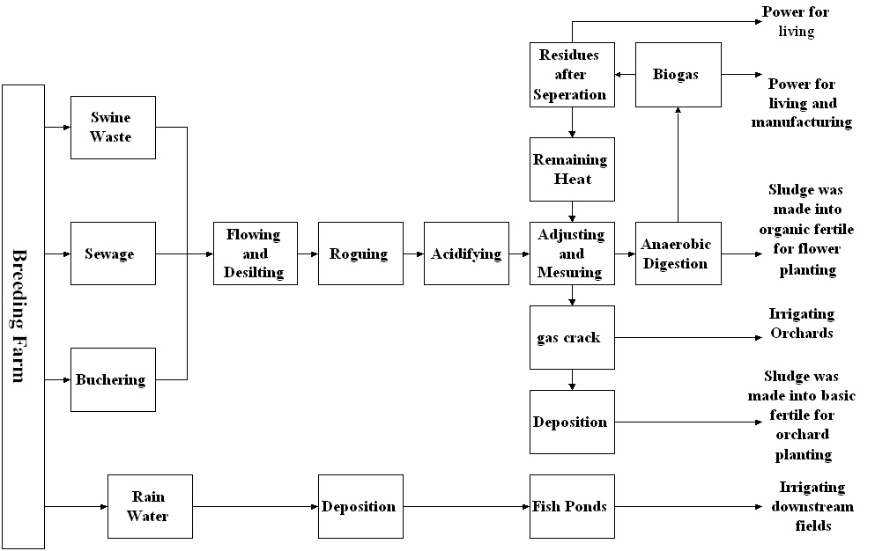

Figure3.1 System Flow Figure

● Main Equipment Water collecting basins with the volume of 20 m³ (two sets)
Metric basins with the volume of 20 m³
Acidifying basins with the volume of 120 m³
Anaerobic Digester with the volume of 350m³ (two sets)
Liquid residues storage pool with the volume of 120 m³
Biogas tank with the volume of 300 m³
Simple depositing basin with the volume of 40 m³
Oxidizing pool with the area of 6,000 m²
Biogas/diesel generator, 45kW and 75kW

C. Main Technical Index
Daily Emission of Pig Waste and Sewage 60 ton/day
CODcr Consistency 20,000 mg/l
Biogas Production Rate 1.2 m³ /m³.day
Daily Biogas Production 840 m³/day
Yearly Biogas Production 3,0240,000 m³/year
Remove Rate of CODcr and NH₃-N above 80%

D. Investment (unit: RMB Yuan)
Total: 1,707,000 100%
In which: Construction 856,000 50.1%
Equipment Installment 662,000 38.8%
Design and Management 189,000 11.1%
Capital Source
Special loan from SETC 1,482,000 86.8%
Self-financing 225,000 13.2%
Annual Operation Cost 200,300
(Including salary, fuels, management, maintenance, and so on)

III. Benefits

A. Environmental protection
Before the implementation of biogas project, the annual discharge of pig waste and sewage is about 98,000 ton. After implementation, water meters were installed in every pig house and dry cleaning technology was adopted. With these endeavors, the annual discharge of pig waste and sewage is controlled to be as blow as 28,000 ton.
After biogas was used as living fuel, villagers didn’t fell the trees in orchards stealthily any more. Solid residues serving as fertilizer also reduces the use of inorganic fertilizer. The ecological environment becomes better than before.
Now the farm has fresh air and no smell again. Both human and livestock have not gotten contagion any more since the implementation. Now the farm has been a place for lying fallow.
B. Energy
Annual availability of biogas is about 260,600 m^{3,} which equal to 130.3 ton LPG or 781.8 ton standard coal
C. Economic gains
The annual revenue of the project is about RMB 402,500 Yuan, among which:
Power Generation 86,400
Biogas for living use 206,600
Organic fertilizer for flower planting 14,300
Savings from liquid residues as fertilizer 95,200

IV. Support form Government and Relative Policies

The breeding farm of Quantou Farm is one of the commercial pork production bases of Fuzhou city and is treated as a price controller of the pork market by Fuzhou municipality. When constructing the biogas power generation project, Fuzhou municipality and district government helped to apply special loan from SETC, which assured the construction of the project.
V. Barriers to Commercial Development

● The price of biogas is RMB 1.00 Yuan/m³. Meanwhile the average price of LPG in the market is about RMB 3.40 Yuan/kg. This price does not reflect the real value of biogas.
● Only 10% of the solid and liquid residues are utilized. The waste part has obvious negative impact on the revenue of the project.
● The environmental gains cannot be reflected in the revenue

VI. Prospect

● Making Organic Fertilizer
Utilize the unused solid and liquid residues to produce organic fertilizer and sell them in the market
● Enlarging the Breeding Farm and Biogas Plant
Because of the demand of market and development of the farm, another breeding farm and biogas plant in the same scale is to be constructed
● Developing characteristic breeding and meatpacking industry

Case 3.2 Investigation on Biogas Plant of Nanhangji Pig Farm, Fangshan District, Beijing

I. Background

Nanhanji Pig Farm is located in Nanhanji Village, Fangshan District in Beijing City. The village is about 50 km to the town center of Beijing and only 5 km to famous Peking Man Ruins. Wajin River, a small river, is the only discharge channel of sewage and flood in the whole village.
Nanhanji Pig Farm is the main source of pollutant in the village. The pig waste and sewage from pigsty was discharged to a deep channel directly, where the pollutant vaporized or filtered through the soil. It smelled bad and polluted the groundwater.

II. Scale of Breeding and Emissions

Designed Annual Turnover of Pigs 10,000
Amount of Pigs on Hand 1,550
Daily Discharge of Pig Waste 20~30m³ ton/d
CODcr consistency of sewage 10,935mg/L
BOD₅ consistency of sewage 5,5795mg/L
NH₃-N consistency of sewage 621mg/L
SS consistency of sewage 13,900mg/L

III. Biogas Plant

A. Objective
The economic bearing capability of the rural area must be considered when choosing the implementation plan of the harness project. The plan with low operation costs is preferred, and the utilization of the resources should reduce the financial burden of the investors.
When harnessing the water environment, the technology of clean production and sewage reduction should be popularized to enhance the use factor of water resource.
Adopting the technology that is acceptable for rural areas. The project should use land rationally.
The pig excrement and sewage are digested. Biogas is supplied to the villagers as domestic fuel. The liquid residue is used to irrigate fields and the solid residues to be made into organic fertilizer.
B. Biogas Plant
● Digester Type Up-Flow Solid Reactor (USR)
● System Flow Figure Referring to figure 3.2
● Main Equipment Mesothermal Digester 373m³
Pressed Biogas Tank with the Volume of 50m³
● Biogas Production Rate 1m³/m³.day

C. Investment (unit: RMB yuan)
Total: 1,890,000
Capital Source
Subsidies from British Kingdom 55.6%
Subsidies from Government 28%
Self-Financing 16.4%
Annual Operation Cost 75,900
(Including salary, fuels, management, maintenance, and so on)

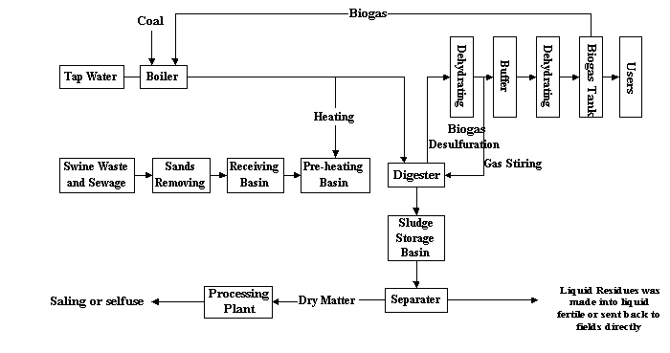

Figure 3.2 System Flow Figure

IV. Benefits

A. Environmental protection
● Diminishing the discharge of pig waste and sewage
● Zero discharge of sewage; the result was shown in table
● The organic contents of the soils increased.

Table 3.2 List of Remove Rates
Item | CODcr | Remove  Rate | BOD₅ | Remove  Rate | SS | Remove Rate
Warming up pool | 11176 | -- | 6460 | -- | 7828 | --
Sludge storage basin | 2580 | 77% | 1228 | 81% | 1952 | 75%
Liquids storage basin | 1434 | 40% | 690 | 43% | 967 | 50%

B. Energy supply
● The biogas is used as living fuel.

C. Economic gains
The annual revenue of the project is about RMB 135,000 Yuan.

Case 3.3 Investigation on Biogas Plant of Dulehe Orchard and Pig Farm, Pinggu County, Beijing

I. Background
Dulehe Orchard and Breeding Farm is located in the Dulehe Town, Pinggu County, 3 km to the west of Jinhai Lake tourist region, and 12 km to the east of Pinggu County Town. A road to some other famous tourist regions of Beijing also passes it.
The land area of the breeding farm is about 300 mu, among which there are 275 mu orchards, and 25 mu breeding farm. The pig house area is about 7000 m² and some appurtenant works occupy 1000 m² land. Now there are 38 staffs in this enterprise, major in pig breeding.
The designed annual turnover of the breeding farm is 10,000 pigs. However, due to the demand and fluctuation of the market, the actual annual turnover is about 5,000~6,000 pigs.

II. Biogas Plant

A. Objective
The annual production of pig excrement in the fastigium was above 20,000 ton, which was piled up casually and flooded everywhere. The environment of the tourist regions and residential areas nearby were polluted heavily.
In 1993, two 40m³ water-press biogas tanks were built to process part of the pig waste and sewage by anaerobic digestion, which improved the environment in some extent. However, there are still some problems to be resolved. First, the digestion ability was very low. The two digesters can only deal with 25% of all the pig waste and sewage. Second, the solid and liquid residues would cause secondary pollution if they couldn't be utilized in due course. Third, the economic benefit was very low.
In order to assure the innocuous treatment of the pig waste and sewage, a new biogas project was under construction. This project should not only utilize resources comprehensively, but also find a new way of harmonious development in society, environment and economy.

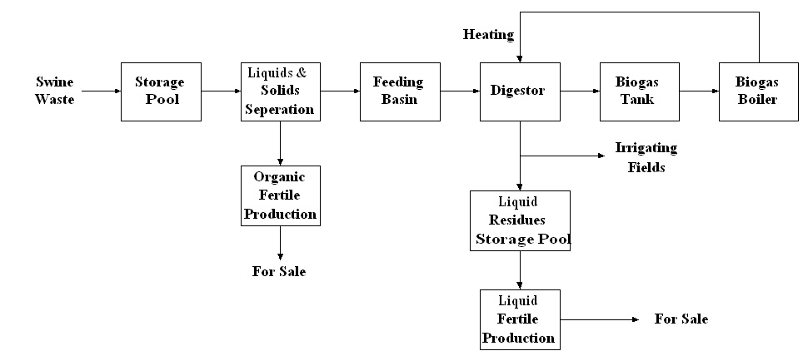

Figure 3.3 System Flow Figure

B. Biogas Plant
● Digester Type Up-Flow Solid Reactor (USR)
● System Flow Figure Referring to figure 3.3
● Main Equipment Normal Temperature Digester 3×60m³
Mesothermal Digester 1×100m³
Biogas Tank with the Volume of 300m³
● Biogas Production Rate Normal Temperature: 0.36m³/m³.day
Moderate Temperature: 1.2m³/m³.day
● Biogas Production 43,200 m³/year

C. Investment (unit: RMB Yuan)
Total: 5,480,000 100%
In which: Construction 1,300,000 23.7%
Equipment 3,280,000 59.8%
Pipe System 800,000 14.6%
Land Cost 100,000 1.9%
Capital Source:
Subsidies from Government 3,980,000 72.6%
Self-Financing 1,500,000 27.4%
Annual Operation Cost: 3,300,000
(Including salary, fuels, management, maintenance, and so on)

III. Benefits
A. Environmental protection
● Diminishing the discharge of pig waste and sewage
● Zero discharge of sewage; the remove rate of COD is over 90%
● The project not only improves the environment quality around the farm, but also boosts the development of the tourist industry.
● The products are all organic goods.

B. Energy supply
● The biogas is used as fuel to maintain the temperature of the digesters.

C. Economic gains
● The biogas project produces 500 ton of liquid nutrition regulator for plant growing and 5,000 ton of organic fertilizer annually, which brings annual revenue of RMB 17,000,000 Yuan and annual profit payments and tax turnover of RMB 6,000,000 Yuan. The Internal Revenue Rate of the project is 33.1%.

IV. Prospects

Both Liquid nutrition regulators for plant growing and organic fertilizer are all organic goods, they represent the tendency of agriculture development.
The potential market is very huge. At present, users from Guangdong, Shandong and Henan have approbated the products. If the products are used on 10% of the land through the whole country, there will be a large market.
Developing new organic products and utilizing resources comprehensively started a new way to spread large-scale biogas plant projects. And with the projects, the environment in and around breeding farms will become better.

Case 3.4 Investigation on Biogas Plant of Gaoqiao Breeding Farm, Chedun Town, Songjiang District, Shanghai

I. Background

Gaoqiao breeding farm is located in the juncture of Minhang District and Songjiang District, 10 m to the east of Dongdun River, which links the Huangpu River directly, and west of about 200 mu orchards and 800 mu cropland of the Gaoqiao village. The breeding farm is only 6km to the water catchments area of Shanghai citizen, included in the water-source reserve of Shanghai municipal planning.
The land area of the breeding farm is about 4.4 hectares (66 mu), and 36 staffs work there. The farm is a polycultural one with both breeding birds and pork pigs, which holds 35,000 breeding birds, 210 boars, producing 3 million chicks and 10,000 pigs in the average year.
The breeding farm discharges 9.7 ton of argol and 76 ton of sewage every day, which was emitted to Dongdun River directly and finally, entered Huanpu River. The effluents not only turned the Dongdun River into a muck ditch, but also polluted the upstream of Huangpu River, which is a main drink water source of Shaihang.
In order to improve the quality of drink water and solve the environmental problems around breeding farms, Shanghai government decided to implement integrated harnessing in the 1600 breeding farms all around the city. This action was an important environmental protection project of Shanghai municipality, who subsidies 2/3 of the initial investment of each biogas plant in breeding farms. In 1999, biogas plants were built in 112 breeding farms, and the biogas plant in Gaoqiao breeding farm was just in that project.

II. Biogas Plant

A. Objective
● Controlling the total emissions of pollutant; argol less than 10 ton and sewage less than 20 ton
● Operating hermetically; no poison and smell; the discharge of sewage must conform to the regulations
● Turning argol to organic fertilizer; irrigating fields with liquid residues; using biogas as fuel

B. Biogas Plant
● Digester Type Up-Flow Anaerobic Sludge Bed Reactor (UASB),
Mesothermal Digestion (28~32)
● Main Equipment Anaerobic Digester with the Volume of 300m³
Biogas Tank with the Volume of 100m³
● Designed Remove Rate of Pollutant (see table 3.3)

C. Investment (unit: RMB Yuan)
Total: 1,348,000 100%
In which: Construction 657,000 48.7%
Equipment Installment 520,000 38.6%
Design and Management 171,000 12.7%
Capital Source
Subsidies from Municipality 898,000 66.6%
Subsidies from District Government
300,000 22.3%
Breeding Farm 150,000 11.1%
Annual Operation Cost 136,000
(Including salary, fuels, management, maintenance, and so on)

Table 3.3 Remove Rate of Pollutant

Item | BOD₅ | CODcr | NH₃-N
Pig waste and sewage | 5000 | 10000 | 500
Water Collecting Basin | 4000 | 8000 | 400
Acidification | 3200 | 6400 | 300
Anaerobic Digestion | 960 | 1920 | 250
Irrigation of Vegetable Field and Orchars | 0 | 0 | 0

III. Benefits of the Plant

A. Environmental protection
● Diminishing the discharge of sewage about 16800 ton annually
● Zero discharge of sewage
● Diminishing the discharge of CO₂ about 10 ton of carbon annually
● Death rate of egg chicken declined from 3% to 0.1%; encephalitis almost didn’t happened in pigs any more; the incidence of bacillary dysentery declined from 20 persons per year to 2 persons per year
B. Energy supply
● Producing 110,000m³ biogas; substituting 100 ton of coal
C. Economic gains
The avenue from biogas and organic fertilizer is RMB 383,000 Yuan annually

IV. Support form Government and Relative Policies

The economy of Shanghai now develops very quickly. The objective of Shanghai is becoming a modern international metropolis before 2010. Therefore, Shanghai municipality thinks highly of environmental protection and is carrying on the environmental improvement project in the town center and the harnessing of Huangpu River. In Songjiang, Jinshan, and Qingpu District, where lies the drinking water catchments, the construction of large scale breeding farm was under restriction. The existed breeding farms should be harnessed with the support of increased subsidies in different batches and different stages. As a result of this endeavor, around the drinking water catchments, the radius of the area without excrement and sewage emissions should be enlarged from 2km in 1994 to 6km in 2000. The subsidies from government increased from RMB 6 million Yuan in 1990 to RMB 123 million Yuan in 1999. The biogas plant in Gaoqiao breeding farm was one of the harnessing projects and received RMB 0.9 million Yuan as subsidy.
The People’s Congress of Shanghai has issued the ordinance on the punishment of excrement and swage discharge in May 1996, which was the first one of the similar regulations national wide. The standard of discharged and prescript of punishment was publicized in Shanghai. From 1999, the scaled breeding farms must get both the permission of breeding and permission of discharge to carry on their business, and those without any permission would be closed.

V. Prospect of Commercial Development

Whether the biogas plant can be operated commercially is determined by its capacity to earn profits from its production (biogas and organic fertilizer). The experiences of Gaoqiao breeding farm indicate that there are still some restrictions on the commercial development of biogas plant. To override these restrictions, some suggestions are given as followings:
● Enhancing management; improving technology, in order to increase the production of biogas and organic fertilizer
● Changing the conception that the products are welfare goods; supplying biogas and organic fertilizer at the market price
● Improving the quality of the product; expanding the market; enhancing the competitive power of the products comparing with LPG and other organic fertilizer in the market
● The government should make relative policies to accelerate the development. It should be confirmed legally that the products in renewable energy and comprehensive utilization of resource be developed firstly.

Case 3.5: Investigation on Biogas Plant and Water Treatment of Dengta Breeding Farms, Hangzhou

I. Background

Hangzhou is the capital of Zhejiang province. In order to supply the large quantity of pork to the citizen, a super large-scale breeding farm was built in the suburb area. Since Hangzhou also a very famous tourist city in China, the environment should be protected specially. With the care and support of SETC, and financed by UNDP and GEF, a biogas plant was built with the breeding farm synchronistically in order to improve the environment quality. This biogas plant was also a demonstrative project of the auxiliary projects in the super large-scale breeding farms.

II. Scale of Breeding and Discharge Amount

● Annual Turnover of Pigs 200,000
● Amount of Pigs on Hand 120,000
● Daily Discharge of Pig waste 185 ton/day
● CODcr consistency of sewage 17,000mg/L
● NH₃-N consistency of sewage 2,500mg/L
● Daily CODcr discharge 51 ton/day

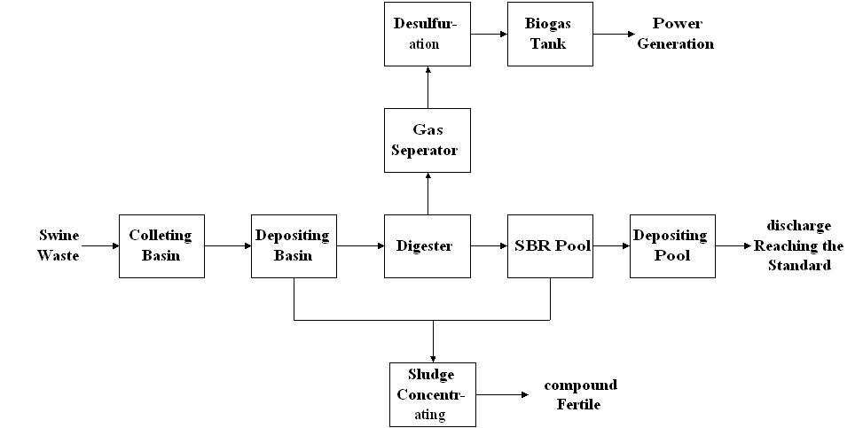

Figure3.4 System Flow Figure

III. Biogas Plant

A. Objective
● Controlling the total discharge of pollutant: implementing clean production; improving breeding technology; separating the wine sludge and sewage by solid liquid separation in order to diminish the discharge of pollutant and utilize the solids completely.
● After the solid-liquid separation of pig waste, the solids were sent to the biologic compost factory to produce organic fertilizer, and the liquids were sent to produce biogas through anaerobic digestion. The biogas was used as living fuel or to generate power.
● Minimizing the harm: the water come from anaerobic digestion must be under biological denitrification and aerobic treatment, and then be sanitized to ensure the discharged water meet the discharge standard
B. Biogas Plant
● Main Equipment Anaerobic Digester with the Volume of 8,000m³
Biogas Tank with the Volume of 1,000m³
Sludge compressor tank with the volume of 900 m³
● System Flow Refer to figure 3.4
IV. Project Implement
Aiming at the characteristics of the pig waste with high consistency, high ammonia nitrogen, large quantity of suspended substance and difficulty of processing, three aspects were treated seriously.
A. Technical Assurance
● Adopting zymotechnics and design parameters of biogas plant meeting advanced world standard
Standardized design and mechanized construction
Solid liquid separation technology and automation
Operation with high efficiency and low costs
● Inviting 5 foreign and local specialists as advisors of the project and absorbing the world advanced technology and experience in order to improve the advantage, reliability and economic benefit of the project.
● Establishing laboratory; researching and validating the design technology through simulated test; optimizing technical flow and design parameters; solving two technical puzzles-biological denitrificaiton and biological desulfuration; providing technical assurance for emissions of the project to reach the standard; accumulating experiences for future construction.
B. Policy Support
● The SETC, SEPA, and UNDP supported the project
● The provincial and local governments supported the project
● Imported equipment was exempted from customs
● The price of biogas power generation was ensured by the government file that the price of resource comprehensive utilization power generation should above RMB 0.53 Yuan/Kw.h
C. Financing (unit: RMB Yuan)
● Subsidies from UNDP/GEF
demonstrative project 3,000,000 20%
● Self-financing 6,000,000 40%
● Bank Loan 6,000,000 40%

V. Technical Economy Index of the Project

A. Processing ability
● Pig Waste 185 ton/day
● Sewage 3,000 ton/day

B. Reduction of Pollutant
● Daily Reduction of COD 50.5 ton/day
● Yearly Reduction of COD 18,450 ton/year
C. Biogas Production 8,519 m³/day
3,110,000 m³/year

D. Biogas Usage
● Biogas Power Generation 13,534 kw.h/day
4,940,000 kw.h/year
● Biogas for Household 1,000 m³/day

E. Others
● Raw material for organic fertilizer 142 ton/day
● Total Investment of the Project RMB 14,970,000 Yuan
● Operation Costs RMB 2,440,000 Yuan/year
● Floor Space 10,000 m²
● Revenue RMB 4,910,000 Yuan/year
Among which
Biogas Power Generation RMB 2,620,000 Yuan/year
Biogas for Household RMB 220,000 Yuan/year
Organic Fertilizer RMB 2,070,000 Yuan/year
● Net Revenue RMB 2,470,000 Yuan/year
● Investment Recovery Period About 7 years

Some pictures of biogas plant of Breeding Farms as follows:

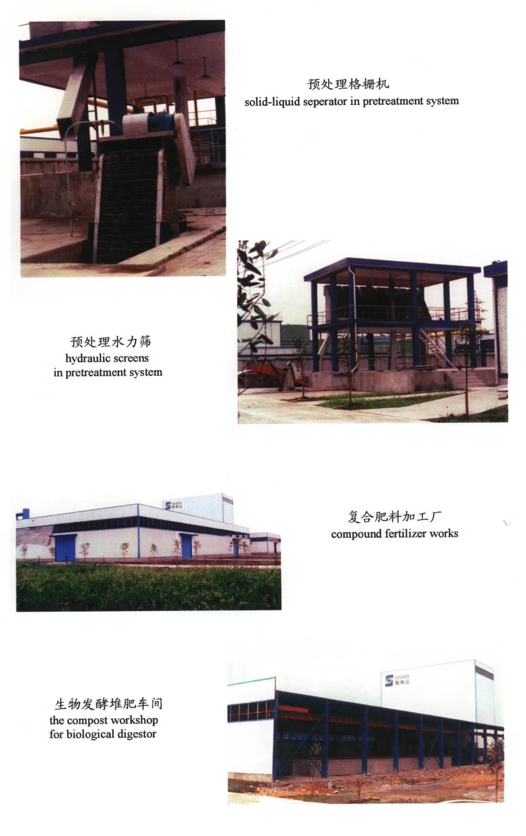

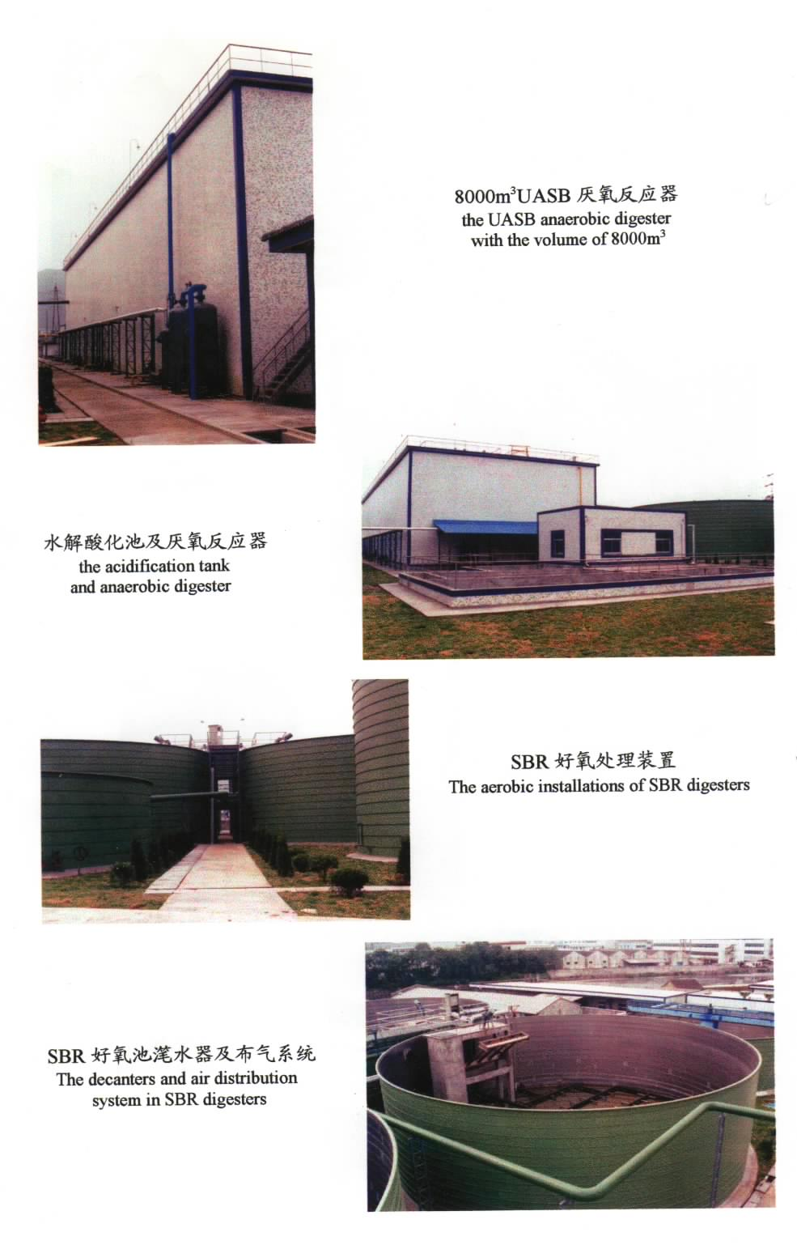

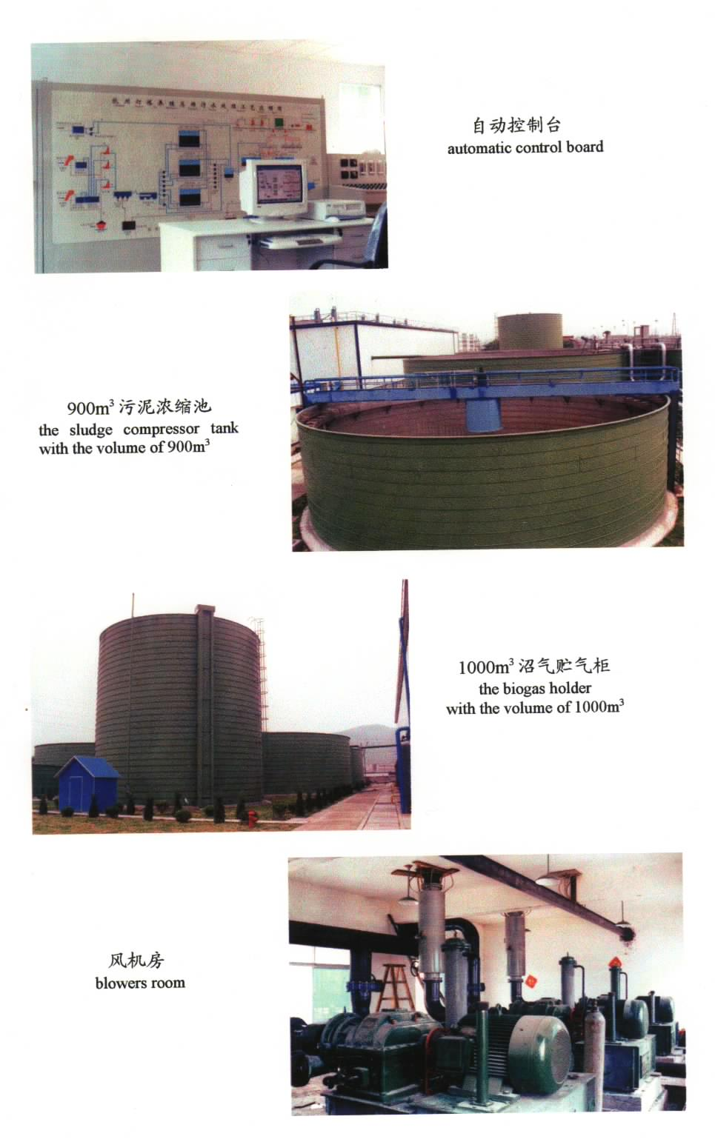

Case 3.6 Investigation on Biogas Plant of Hongming Breeding Farm, Shanxi

I. Background

Hongming Breeding Farm is located in the southeast suburb of Taiyuan City, adjoining to the conventional agriculture areas. The breeding farm is one part of Shanxi Hongming Breeding Co., Ltd., a private company whose business includes breeding, butchering, meet dividing, cooked food making, and vegetable planting. Now, the breeding farm and butchering factory is about 100 mu and another 100 mu land serves as pot garden.

II. Scale of Breeding and Discharge

● Amount of Adult Pigs on Hand 3,700
● Amount of piglets on Hand 1,080
● Daily Discharge of Pig waste 26.9 ton/day
● Daily Discharge of sewage 20 ton/day

III. Biogas Plant

A. Objective
● The biogas plant was built in order to solve the pollution problem and improve the environmental and sanitary quality around the breeding farm.
● Pig waste and sewage enters anaerobic digester after size mixing and rouging. After the solid liquid separation, the solids are sent to produce composed organic fertilizer, and the liquids are used to irrigate the pot garden. Biogas is piped into staff dining hall and villagers’ house nearby as living fuel.
● All of the project is operated in a closed circulation and reaches the sanitary standards. And the project should to be a demonstration of utilizing resources comprehensively.

B. Biogas Plant
● Digester Type Anaerobic Digestion
● System Flow Figure Referring to Figure 3.5
● Main Equipment Anaerobic Digester with the Volume of 500m³
Biogas Tank with the Volume of 300 m³
● Main Index
Biogas Production Rate 2 m³/day.m³
Liquid Residues 45 ton/day
CODcr Remove Rate 85%
TS Decompose Rate 50%

C. Investment (unit: RMB Yuan)
Total: 1,525,000 100%
In which:
Construction 643,000 42.2%
Equipment Installment 745,000 48.8%
Design and Management 137,000 9.0%
Capital Source
Loans 70~80%
Self-Financing 20~30%
Annual Operation Cost 170,000
(Including salary, fuels, management, maintenance, and so on)
Investment recovery period 3~5 year

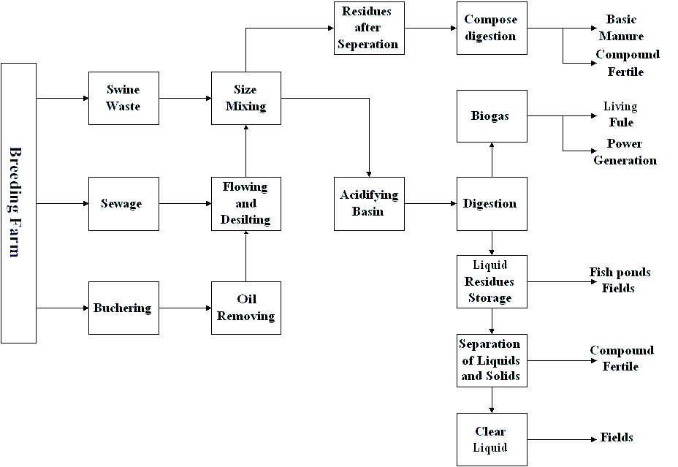

Figure 3.5 System Flow Figure

IV. Benefits

A. Environmental protection
● Zero discharge of sewage
● Environmental Protection has met the standards
● Sterilizing rate of pathogenic bacteria is more than 96%
B. Energy supply
● Producing about 200,000m³ biogas yearly; substituting 446 ton of standard coal, or 87.6 ton of LPG
C. Economic gains (unit: RMB Yuan)
● Annual Total Revenue 677,400
In which: Biogas 297,800
Liquid Residues 146,000
Solid Residues 232,600
Annual Total Costs 170,000
Annual Net Revenue 507,400

V. Support form Government and Relative Policies
Although the implementation of this project was a business action of a private company, the project still got some preferential policies from the local government for its function of environmental protection. The local government assured that the project could get the loans it needed and support it in the technology, examination and approval.

Case 3.7 Investigation on Biogas Plant of Jingshan Pig Farm, Hubei Province

I. Background for constructing the Biogas Plant

Jingshan Pig Farm is a state-owned farm, located in the suburb of Jianshan County, Hubei province, and only 2 kilometers from the town center. The land area of the Farm is 190 hectares, including 4 pig production areas (branch pig farms), 540 mu of crop fields, 500 mu of woodland 300 mu of fish ponds and a residence area for a working staffs of 197 and their families. Besides some breeding pigs, the farm has been commercialized to produce fattened pigs for the market, with an annual turnover of 20,000 pigs, of which a half are exported to Hong Kong market.
The Farm owns two feed-processing plants, one of which now produces 8,000 ton of nutritionally balanced feed per year for direct use of feeding pigs, while the other produces feed ingredients, about 400 ton per year, as inputs for the first plant.
Originally, the idea for establishing the biogas plant was to treat all the wastes produced from the Farm and thus resolve the environmental problem caused by untreated manure and effluent. The project implementation was divided into three phases and a total digesting capacity of 1,100 cubic meters was planed. However, due to the shortage of resources, only the first phase of the project was completed, which is located on one of the four branch farms, Zhaoling Branch Farm, and hence the project did not achieve its main objective aimed at the environmental issues.
At the present time, Zhaoling Branch Farm produces 24 ton fresh manure per day, of which only 2.6 ton are used as input to the digester, while the remainder is sold to neighboring farm households as fish feed and fertilizer. The daily volume of effluent produced is about 180 cubic meters, which are discharged into an irrigation ditch nearby without adequate treatment being made to meet the state environmental standards.

II. Biogas Plant

A. Objective
● Solving the problem of the pollution
● Supplying energy for people’s daily living
B. Biogas Plant
● Digester Type Up-Flow Anaerobic Sludge Bed Reactor (UASB),
Mesothermal Digestion
● System Flow Figure referring to figure 3.6
● Main Equipment Biogas Digester with the Volume of 200m³
Biogas Tank with the Volume of 80m³
Water Bosh Pool with the Volume of 100m³
C. Investment (unit: RMB Yuan)
Total: 341,000
Annual Operation Cost 21,000
(Including salary, fuels, management, maintenance, and so on)
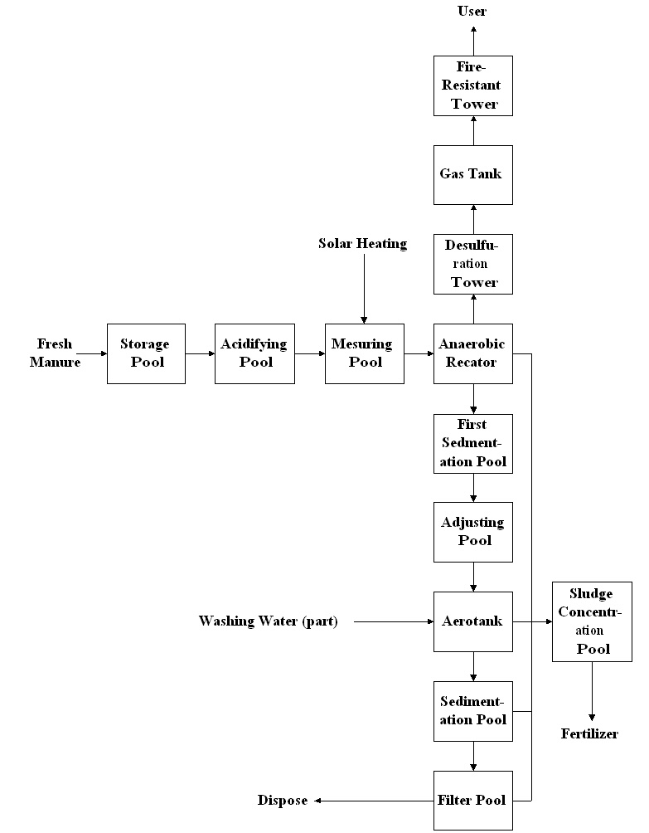

Figure 3.6 System Flow Figure

III. Benefits of the Plant
A. Environmental protection
● Diminishing the emission of soot and dusts about 1031kg, SO₂ about 71kg annually
● 2,630 ton of manure and 31,000 ton of sewage were dispose by the biogas project every year, reducing the pollution on water body and atmosphere
● The sludge and residues used as fertilizer could reduce the chemical fertilizer consumption
B. Energy
● Producing 40,500m³ biogas; substituting 81 ton of coal
C. Economic gains
Assuming that the price of biogas is RMB 1.3 Yuan per cubic meter, the value of annual production is 65,520 Yuan

IV. General Assessment

● The biogas plant on the Jingshan Pig Farm is a salvage of an uncompleted environment protecting and gas-generating project. The main project objective of environment conservation is not achieved.
● If the biogas plant were operated in a commercial way, it could have been a profitable enterprise supplying cooking gas to users

Annex Investigation Outline on Biogas Plant Cases of Breeding Farms

- Background
- General Information of the Breeding Farm: Location, Surroundings, Floor Area, Employee, breed in the farm (pigs, cattle or chicken), Number of These Breeds and the Production.
- Background for Constructing the Biogas Plant
The Environmental Issues before the Biogas Plant Construction, Amount of Discharged Excrement and Urine Effluents, Discharge of Sewage, Pollution of Surroundings.
Analysis on the Reasons for Constructing the Biogas Plant,
From the Farms and Government’s view the Object of the Biogas Plant Construction.
- Biogas Plant
- Scale of the Plant
Number of Digesters, Unit Volume and Total Volume
Auxiliary and Supporting Facility
Pipeline System
Post-Processing System
- Technics
Type of Digesters, fermentation Temperature, Blending Mode, Material Input and Output
- System Flow Figure
- Main Index in Technique
Organic Load Factor kgcod/m3.day
Biogas Production Rate m3/m3.day
Annual Biogas Production m3/year
Remove Rate of BOD and COD From __% to __%
PH Value From __ to __
Remove Rate of Suspended Matter %
- Construction Period and Operation year
- Input of the Biogas Plant
- Initial Investment: Capital Resource and Capital Composition
Total Investment: the Unit Price and Total Price of Building Projects, Equipment, Pipeline System, Post-Processing system and land
- Operational Costs: the Unit Price and Total Price of Raw materials, Fuels, Power, human labor, servicing materials, component parts and others
- Output (Biogas, Solid Residues and Liquid Residues)
- Yield, Unit Price, Total Income of the Gas Production, Annual Gas Supply to Residents, How to Operate the Biogas Plant If the Gas Supply Is Treated as Welfare?
- Usefulness, Yield, Unit Price and Total Income of the Solid and Liquid Residues.
- Environment Gains
Annual processing amount of pig waste
Annual discharge of sewage
Has the discharge reached the standard of zero emission?
What measure was adopted to reduce the emission?
Annual deduction of environmental pollution costs
Deduction of diseases and enhancement of health level
How Incidence of diseases changed of the breeds?
Enhancement of sanitary conditions
- Support from Government and Relative Policy
Support from Government in Finance and Other Fields, Enumerating the Specific Policy
- Total Evaluation and Development Potential
Analysis with/without Biogas Plant, Analysis on the Barriers of Commercialization, Experience and Lessons, Potential and Prospect

